9th Meeting of SLBC of Telangana

: Date & Time :
7th January 2016 at 3.30 p.m.
: Venue :
Auditorium
State Bank of Hyderabad
Head Office : Hyderabad

Agenda & Background Papers

STATE LEVEL BANKERS’ COMMITTEE
TELANGANA

Convener

State Bank of Hyderabad
Head Office : Hyderabad

9th SLBC Meeting Agenda – Index
- Adoption of Minutes

S.No. | Particulars | Page No.
1.1 | Adoption of minutes of 8th SLBC meeting held on 04/09/2015 and adoption of minutes of other meetings of SLBC held on various dates. | 9

- Banking Statistics

S.No. | Particulars | Page No.
2.1 | Banking at a Glance in Telangana | 9
2.2 | Data as at the end of – Sept., 2015 | 10
2.3 | Banking Key Indicators | 12
2.4 | Statement of Priority Sector Advances | 14

- Achievement of Annual Credit Plan 2015-16

S.No. | Particulars | Page No.
3.1 | Achievement as on 30.09.2015 | 16

- Agriculture Sector

S.No. | Particulars | Page No.
4.1 | Progress in lending short term production loans | 17
4.2 | Vaddileni Runalu and Pavala Vaddi Scheme on crop loans for Kharif & Rabi 2015 | 18
4.3 | Union Budget-2015 – Interest subvention scheme for short term crop loans during the year 2015-16 – RBI circular no. RBI/2015-16/152 FIDD No. FSD.BC. 59/05.04.02/2015-16 dt. 13/08/2015 | 18
4.4 | NAIS – Cut-off dates for payments of Insurance Premium for all notified crops by the non-loanee farmers | 19
4.5 | Targets for financing of JLGs for the year 2015-16 | 19
4.6 | Indira Kranthi Patham – Targets for 2015-16 | 20
4.7 | Poultry farming – Reschedulement of loans on account bird-flu | 20
4.8 | Pledge financing against Negotiable warehouse receits (NWRs) | 20
4.9 | Agri-clinics & Agri-business Centres (SCABC) – Review of progress | 22
4.10 | Dairy Entrepreneurship Development Scheme (DEDS) – Continuation of the scheme for the financial year 2015-16 | 23
4.11 | Over-dues / NPAs under Agriculture Sector as on 30.09.2015 | 24

- Micro, Small & Medium Enterprises (MSME) Sector

S.No. | Particulars | Page No.
5.1 | Position of Lending under MSME sector | 26
5.2 | Overdue / NPAs under MSME sector | 27
5.3 | PMEGP Targets for the year 2015-16 | 28
5.4 | Pradhana Manthri Mudra Yojana (PMMY) | 28
5.5 | Streamlining flow of credit to Micro and Small Enterprises (MSEs) for facilitating timely and adequate credit flow during their ‘Life Cycle’ | 30
5.6 | CGTMSE Scheme – Progress made by banks during the year upto 30/09/2015 | 31
5.7 | Specialized MSME branches in the state of Telangana | 32
5.8 | Rehabilitation of sick Micro & Small enterprises | 32
5.9 | Review of Revival of sick MSE units at District level | 33
5.10 | Implementation of Modified REMOT scheme renamed as ‘Coir Udyami Yojana (CUY)’ | 33
5.11 | Non-adherence of RBI guidelines on security / co-obligation and keeping register for rejected loans for recording the reasons | 34
5.12 | Implementation of PMEGP | 34

- Housing Loans

S.No. | Particulars | Page No.
6.1 | Position of housing Loans as on 30/09/2015 | 34
6.2 | Over dues / NPAs under housing loans 30/09/2015 | 35

- Education loans

S.No. | Particulars | Page No.
7.1 | Position of Education loans as on 30/09/2015 | 35
7.2 | Overdue / NPAs under Education Loans as on 30/09/2015 | 35
7.3 | Dr. Ambedkar Central Sector Scheme of Interest subsidy on Education loan for overseas studies for other backward classes (OBCs) (effective from 2014-15) | 36
7.4 | Dr. Ambedkar Central Sector scheme for interest subsidy on education loan for overseas studies for economically backward classes (EBCs) (effective from 2014-15) | 37

- Credit flow to Minority Communities

S.No. | Particulars | Page No.
8.1 | Credit flow to Minority Communities | 38
8.2 | Overdue / NPAs under loans to Minority community | 38

- Credit flow to Weaker Sectors

S.No. | Particulars | Page No.
9.1 | Credit flow to Weaker Sections | 39
9.2 | Overdue / NPAs under Loans sanctioned to Weaker Sections | 39

- Credit flow to SC/STs

S.No. | Particulars | Page No.
10.1 | Credit flow to SC/STs | 39
10.2 | Overdue / NPAs under loans to SC/STs | 40

- Credit flow to Women beneficiaries

S.No. | Particulars | Page No.
11.1 | Credit flow to Women beneficiaries | 40
11.2 | Overdue / NPAs under loans to Women beneficiaries | 41

- Government Sponsored Schemes – Government of India

S.No. | Particulars | Page No.
12.1 | NRLM | 41
12.2 | Position of implementation of government sponsored schemes during the financial year 2015-16 – Central Government. | 42
12.3 | Flow of credit under DRI scheme | 42
12.4 | Overdue / NPA position under DRI scheme as on 30/09/2015 | 42

- Government sponsored Schemes – Government of Telangana

S.No. | Particulars | Page No.
13.1 | Targets – 2015-16 (all state government sponsored schemes) | 42
13.2 | State Government sponsored schemes (all schemes) | 43
13.3 | Performance / Disbursement of Loans under Government sponsored schemes (all schemes) | 43

- Financial Inclusion

S.No. | Particulars | Page No.
 | Road Map for Providing Banking channels / services:
14.1 | Providing banking services in all villages with above 2000 population - progress as on 30.09.2015 | 44
14.2 | Implementation of FIP in below 2000 population – Progress as on 30.09.2015 | 44
14.3 | National Mission on Financial Inclusion Plan – Pradhan Mantri Jan-dhan Yojana (PMJDY) | 44
14.4 | Performance of Social security schemes | 45
14.5 | IBA-CYFI collaboration – School Bank Champs project | 45
14.6 | Unbanked mandals / Mandals with no bank branches in Mandal Head quarters | 45
14.7 | Opening of branches in Tribal areas | 46
14.8 | Online VIP reference tracking module with banks / SLBC | 46
14.9 | Installation of ATMs | 46
14.10 | UIDAI –Scheme for Deployment of Micro ATMs – extension of date | 47
14.11 | Financial Literacy centres (FLCs – position) | 47
14.12 | Availability of standardized financial literacy material of RBI at FLCs | 48
14.13 | Financial Literacy activity by rural branches and FLCs | 49
14.14 | Rural Self Employment Training Institutes in Telangana (RSETIs) | 50
14.15 | Certification of Bank Mitras / Business Correspondents & Business Facilitators (BM / BC / BFs) by IIBF | 50
14.16 | Spread of Financial Literacy in Government approved Industrial Training Institutes (ITIs) across the country | 51
14.17 | Success stories of FLCs and BCs
14.17.1 | DCCB-FLC- Ms. Md. Sartaj – Success story | 52
14.17.2 | FLC-Sathupally – Success story | 52
14.17.3 | BC of APGVB – M. Vijayalaxmi – Success story | 52
14.17.4 | RSETI-SBH – Success story | 53
14.17.5 | Smt. Habib Sultana – Trainee – Success story | 54
14.17.6 | Smt. K Vijaya – Trainee – Success story | 54
14.17.7 | Smt Asha Begum – Trainee – Success story | 54
- Lead Bank Scheme:

S.No. | Particulars | Page No.
15.1 | Attendance in JMLBC / DLRC / DCC meetings | 55
15.2 | Information to be submitted quarterly by banks and LDMs | 55
15.3 | Communicating the decisions taken at SLBC level to the branches by the controlling authorities | 55
15.4 | Strengthening of LDM’s office | 56

- Overdue / NPAs position of various sectors / schemes

S.No. | Particulars | Page No.
16.1 | Overdue / NPAs position as on 30.09.2015 under various sectors | 57
16.2 | Overdue / NPAs – total position as on 30.09.2015 under State Government sponsored schemes | 58
16.3 | Overdue / NPAs position as on 30.09.2015 under State Government sponsored schemes | 59
16.4 | Overdue / NPAs position as on 30.09.2015 under Central Government sponsored schemes | 61

- Regional Rural Banks (RRBs)

S.No. | Particulars | Page No.
17.1 | Performance of Regional Rural Banks on important parameters | 63
17.2 | RRBs- Network | 63
17.3 | RRBs – Deposits | 63
17.4 | RRBs – Advances | 64
17.5 | RRBs - CD Ratio | 64
17.6 | RRBs – Total Agri. Advances % in total advances | 65
17.7 | RRBs – Total Agri. Advances | 65

- Other Agenda items to be discussed

S.No. | Particulars | Page No.
18.1 | NULM | 67
18.2 | Loans under MUDRA scheme | 67
18.3 | Allotment of land to RSETI-Khammam | 67
18.4 | District-wise targets – PMEGP Scheme of KVIC | 68
18.5 | NABARD agenda items | 68
18.6 | Inclusion of Skill Loan Financing | 68
18.7 | Inclusion of members in the SLBC meetings | 69
18.8 | OSS Centres under TRIGP – Allotment of Gram Panchayats for BC operations | 69
18.9 | Drought – Declaration of 231 mandals in 7 districts of the State as drought affected | 70
18.10 | Housing for All (Urban) under Pradhan Mantri Awas Yojana | 70

- Circulars issued by Reserve Bank of India/NABARD/GoI/GoT

S.No. | Particulars | Page No.
19.1 | Circulars issued by RBI / NABARD / Govt. of India / Govt. of Telangana | 72

- Position of Top 10 Banks (Table & Graphs)

S.No. | Particulars | Page No.
20.1 | Position of top 10 banks – Deposits | 74
20.2 | Position of top 10 banks – Advances | 74
20.3 | Position of tep 10 baks – Total Business | 75
20.4 | Oustanding of Micro, Small and Medium Enterprises (MSME) | 75
20.5 | Position of top 10 banks – Total Priority Sector Advances | 76
20.6 | Break-up of Agriculture Advances - Disbursals | 76
20.7 | Break-up – Disbursement to Priority Sector Advances | 77
20.8 | Break-up of priority sector advances – activity wise | 78
20.9 | Achievement of annual targets – segment-wise | 79

- Annexures

S.No. | Particulars – Position as on 30/09/2015 | Page No.
21.1 | Bank-wise number of branches, deposits, advances | 80
21.2 | District-wise number of branches, deposits, advances | 82
21.3 | Bank-wise Deposits; Advances & CD Ratio | 83
21.4 | District-wise Deposits; Advances and CD Ratio | 85
21.5 | Bank-wise Priority Sector Advances | 86
21.6 | District-wise Priority Sector Advances | 88
21.7 | Bank-wise Agriculture Advances (Direct & Indirect) | 89
21.8 | District-wise Agriculture Advances (Direct & Indirect) | 93
21.9 | Annual Credit Plan 2015-16 : Bank-wise achievement (Agriculture) | 94
21.10 | Annual Credit Plan 2015-16 : Bank-wise achievement (MSE & Priority Sector Advances) | 96
21.11 | District-wise achievement of Annual Credit Plan 2015-16 (Agriculture) | 98
21.12 | District-wise achievement of Annual Credit Plan 2015-16 (MSE & Priority Sector Advances) | 100
21.13 | Bank-wise Micro; Small & Medium Enterprises (MSME) advances | 102
21.14 | Bank-wise Housing Loans | 106
21.15 | Bank-wise Education Loans | 108
21.16 | Bank-wise Education Loans targets allocated in the State of Telangana | 110
21.17 | Bank-wise data on Export Credit | 112
21.18 | Bank-wise Advances to Minority Communities | 114
21.19 | Bank-wise Advances to Weaker Sections | 116
21.20 | Bank-wise Advances to SC / ST borrowers | 118
21.21 | Bank-wise Advances to Women | 120
21.22 | Bank-wise Advances under DRI scheme | 122
21.23 | Bank-wise SHG Bank-linkages | 124
21.24 | Bank-wise Loans under NRLM scheme | 126
21.25 | Ban-wise loans to Milch-animals | 128
21.26 | Bank-wise loans to Sheep & Goat units | 130
21.27 | Bank-wise loans under SERP | 132
21.28 | Bank-wise loans under MEPMA | 134
21.29 | Bank-wise loans under Rajeev Gruhakalpa Scheme | 136
21.30 | Bank-wise loans under VAMBAY Scheme | 138
21.31 | Bank-wise loans under Rajeev Yuva Shakti Scheme | 140
21.32 | Short Term Crop Production Loans : Bank-wise position on overdue / NPAs | 142
21.33 | Agri. Term Loans including Allied Activities : Bank-wise position on overdue / NPAs | 144
21.34 | Agri. Term Loans including Allied – Indirect Loans : Bank-wise position on overdue / NPAs | 146
21.35 | Total Agriculture advances : Bank-wise position on overdue / NPAs | 148
21.36 | Micro & Small Enterprises : Bank-wise position on overdue / NPAs | 150
21.37 | ‘Others’ under Priority Sector Advances : Bank-wise position on overdue / NPAs | 152
21.38 | Total Priority Sector Advances : Bank-wise position on overdue / NPAs | 154
21.39 | Non-Priority Sector Advances : Bank-wise position on overdue / NPAs | 156
21.40 | Total Advances : Bank-wise position on overdue / NPAs | 158
21.41 | Educational Loans : Bank-wise position on overdue / NPAs | 160
21.42 | Housing Loans : Bank-wise position on overdue / NPAs | 162
21.43 | SHGs Bank Linkage : Bank-wise position on overdue / NPAs | 164
21.44 | Bank-wise Targets : NULM / NRLM – 2015-16 | 166
21.45 | Bank-wise district-wise JLG targets – 2015-16 | 188
21.46 | Roadmap-Provision of Banking services in villages with population below 2000-RBI Circular | 189
21.47A | FIP>2000 District-wise position | 192
21.47B | FIP <2000 District-wise and Bank-wise position | 193
21.48 | Financial Literacy Centres – Report 31/09/15 – Report I & II | 198
21.49 | Enrollment data of Social Security Schemes | 202
21.50 | Position of FLCs | 207
21.51 | Position of DCCB-FLCs | 210
21.52 | Performance report on RSETIs | 212
21.53 | Details of Claims submitted (pending) by RSETIs | 213
21.54 | Certification of BM/BC/BF by IIBF – IBA letter & Mail | 214
21.55 | Mapping of Govt. ITIs | 220
21.56 | Mapping of Private ITIs | 223
21.57 | Mapping of Skilling Centres | 243
21.58 | IBA / CYFY – School Bank Charms Project | 264
21.59 | Govt. of Telangana – GO on VLR scheme | 268
21.60 | Union Budget 2015-16- Interest Subvention | 270
21.61 | Targets of Indira Kranthi Patham | 274
21.62 | RBI Cir. On reschedulement of Poultry farm loans on account of Bird-flu | 278
21.63 | KVIC – District-wise targets 2015-16 | 279
21.64 | MUDRA – Sishu Category – Application form in Telugu | 280
21.65 | MUDRA Scheme – Application form in Telugu | 282
21.66 | Bank-wise targets under MUDRA scheme | 286
21.67 | National Crop Insurance Scheme - Extension of cut off date for enrolment of Loanee farmers for all the notified crops. | 287
21.68 | Swarojgar Credit Card Targets for FY 2015-16 | 300
21.69 | Weaver Credit Card Targets for FY 2015-16 | 303
21.70 | Minutes of Steering committee Meeting on Agriculture | 306
21.71 | Proceedings of 1st Steering Committee of MEPMA | 309
21.72 | Minutes of SLIIC-sub Committee Meeting | 312
21.73 | Proceedings of 1st sub-committee meeting on RSETIs | 317
21.74 | Minutes of combined 5th EC & SLIIC Meeting on MSME | 320
21.75 | Proceeding of 8th SLBC Meeting | 329
21.76 | Minutes of VC Meeting on SSS scheme | 344
21.77 | Proceedings of 4th PMJDY implementation steering committee | 346
21.78 | RBI letter - NULM – Inclusion as an agenda in sub-committee of SLBC | 351
21.79 | Letter of MSME – Loans under MUDRA scheme to Trainees | 353
21.80 | Allotment of Land to RSETI - Khammam | 354
21.81 | District-wise Targets of KVIC scheme (Revised) | 355
21.82 | NABARD Schemes as per new priority sector lending norms | 359
21.83 | GOI letter – Skill Loan Financing | 378
21.84 | Inclusion as a member in SLBC –M/s. Sa-Dhan | 381
21.85 | OSS Centre under TRIGP – Letter from APGVB | 383
21.86 | GO on Drought declared in 231 mandals | 384
21.87 | Pradhan Mantri Awas Yojayna – GOT GOs | 393
21.88 | Consolidated Comprehensive Quarterly Data - Sept.2015 – Public Sector Banks | 398
21.89 | Consolidated Comprehensive Quarterly Data - Sept.2015 – Private Sector Banks | 406
21.90 | Consolidated Comprehensive Quarterly Data - Sept.2015 – Commercial Banks | 414
21.91 | Consolidated Comprehensive Quarterly Data - Sept.2015 – Co-op Banks | 422
21.92 | Consolidated Comprehensive Quarterly Data - Sept.2015 – Regional Rural Banks | 430
21.93 | Consolidated Comprehensive Quarterly Data – Sept .2015 – Banks / Financial Institutions | 438

Agenda 1:
  - Adoption of minutes of 8th SLBC meeting held on 04/09/2015
& other meetings of SLBC held after 04/09/2015

The minutes of 8th SLBC meeting held on 4th September 2015 was circulated to the members of SLBC, RBI, NABARD, LDMs and Government Departments concerned. The minutes of sub-committee meetings and other steering committee meetings held after 30/06/2015 were circulated to the members of the SLBC, RBI, NABARD, LDMs and Government Departments concerned. Details of the meetings held are furnished below:

S.No. | Name of the meeting | Date of meeting held
1 | Steering Committee on Agriculture waiver | 20.07.2015
2 | MEPMA Steering Committee meeting | 20.07.2015
3 | SLICC sub-committee meeting | 24.07.2015

These minutes may be taken as approved by the house as no amendments / changes were received by SLBC of Telangana.
Agenda 2:

  - Banking at a glance in Telangana as on 30.09.2015

Rural | Semi-urban | Urban | Metro | Total
1735 | 1158 | 639 | 1434 | 4966
Bank-wise & District-wise number of branches is enclosed as Annexure 1.
Population group wise number of branch as at the end of 30th September 2015.
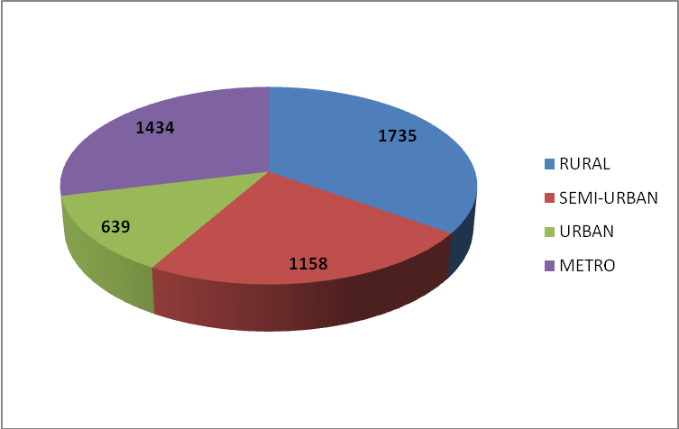

- During the financial year 2015-16 up to Sept. 2015, banks have opened 16 branches.

2.2 Data as at on 30/09/2015:
(Rs. In cr)
S.No. | Particulars | Amount
1 | Total Deposits | 337749.95
2 | Total Advances | 350884.88
2 | Credit Deposits Ratio (%) (RBI Norm 60%) | 103.89%
4 | Total Priority Sector Advances | 115574.88
5 | % of Priority Sector Advances to total Advances (RBI Norm 40%) | 32.94%
 | Of which
A | Agriculture advances | 52102.90
 | % of Agri. Advances to Total Advances | 14.85%
B | Non-farm Sector / Micro & Small Enterprises | 35837.48
 | % to Total Advances | 10.21%
C | Export Credit | 100.69
D | Others' under Priority Sector Advances | 27533.81
 | % to Total Advances | 7.85%
 | Of which
 | i. Educational Loans | 3239.95
 | ii. Housing Loans | 17569.01
 | iii. Others | 6724.85
6 | Advances Weaker Sections | 26804.01
7 | Advances to Women | 26337.16
8 | Advances to SC/ST | 8123.29
9 | Advances to Minorities (RBI Norm 15% on Priority Sector Adv. | 8960.92
Highlights of performance of the Banks during the quarter under review:
- Total deposits grew by Rs.7474.83 cr.
- Total advances grew by Rs.2201.95 cr.
- Priority sector advances of Rs.11636.32 disbursed.
- Short term production loans of Rs. 6909.44 cr. disbursed.
- Term loans of Rs. 1673.74 cr. to agriculture and allied activities disbursed.
- MSME loans / advances amounting to Rs. 1672.54 cr. disbursed.
- Education loans of Rs. 258 cr. disbursed.
- Housing loans of Rs. 543.63 cr. disbursed.
- Disbursals to weaker sections, minorities & SC/STs are Rs. 4803.77 cr., Rs.505.53 cr. and Rs. 1549.06 cr. respectively.

Deposits: Comparative figures of deposits (Rs. In crore)
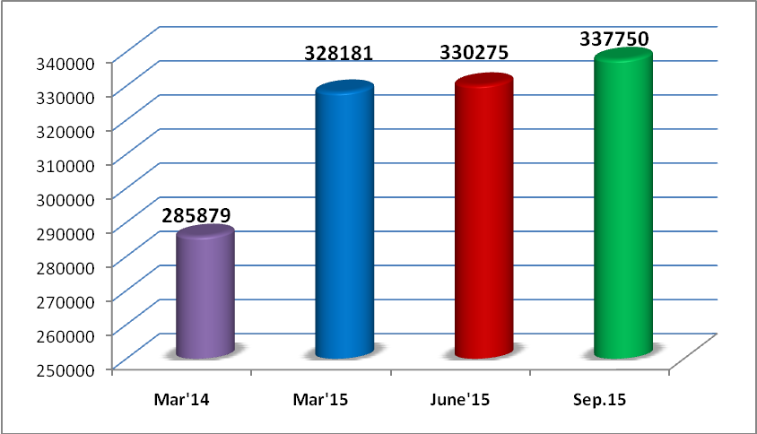
Advances: Comparative figures of advances (Rs. In crore)
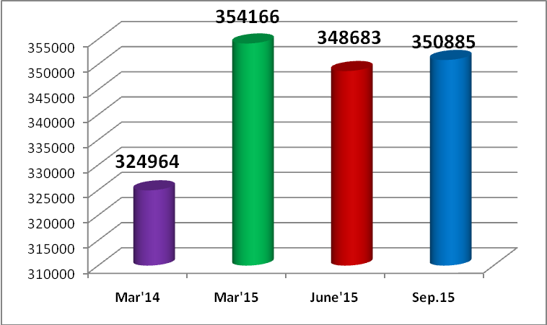
Priority sector advances as at the end of Sept. 2015
(Rs. In crore)
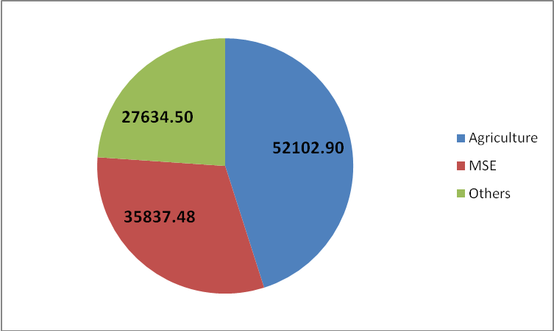

  - Banking Key Indicators of Telangana (Rs. In cr)

S.No. | Particulars | Mar'12 | Mar'13 | Mar'14 | Mar'15 | June'15 | Sep.15
1 | Number of Branches
 | Rural | 1296 | 1450 | 1584 | 1719 | 1719 | 1735
 | Semi-urban | 839 | 955 | 1056 | 1143 | 1147 | 1158
 | Urban | 648 | 662 | 595 | 652 | 652 | 639
 | Metro | 1044 | 1115 | 1317 | 1405 | 1455 | 1434
 | Total | 3827 | 4182 | 4552 | 4919 | 4973 | 4966
2 | Deposits | 219503.00 | 254728.00 | 285879.00 | 328181.11 | 330275.12 | 337749.95
3 | Incremental Deposits (% of increase) |  | 35225.00 | 31151.00 | 42302.11 | 2094.01 | 7474.83
3 | Incremental Deposits (% of increase) |  | 16.05% | 12.23% | 14.80% | 0.64% | 2.26%
4 | Advances | 253497.00 | 301912.00 | 324964.00 | 354165.67 | 348682.93 | 350884.88
 | Incremental Advances (% of increase) |  | 48415.00 | 23052.00 | 29201.67 | -5482.74 | 2201.95
 | Incremental Advances (% of increase) |  | 19.10% | 7.64% | 8.99% | -1.55% | 0.63%
4 | CD Ratio (RBI Norm 60%) | 115.49% | 118.52% | 113.67% | 107.92% | 105.57% | 103.89%
- Bank-wise number of branches, deposits and advances is enclosed as Annexure 1.
- District-wise number of branches is enclosed as Annexure 2.
Comparative position of number of branches
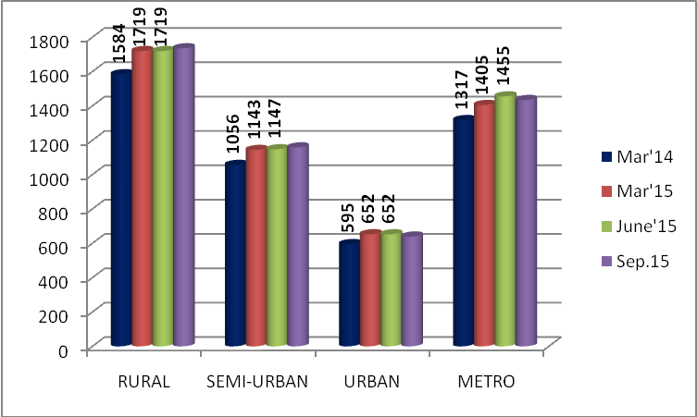

There is minor variation in number of urban branches which is on account of wrong classification of branches by a public sector bank, now rectified.

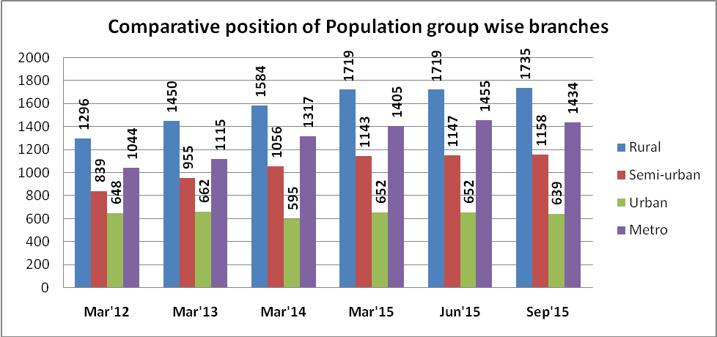

Deposits and Advances : Comparative position from March 2012 to Sept. 2015.
(Rs. In crore)

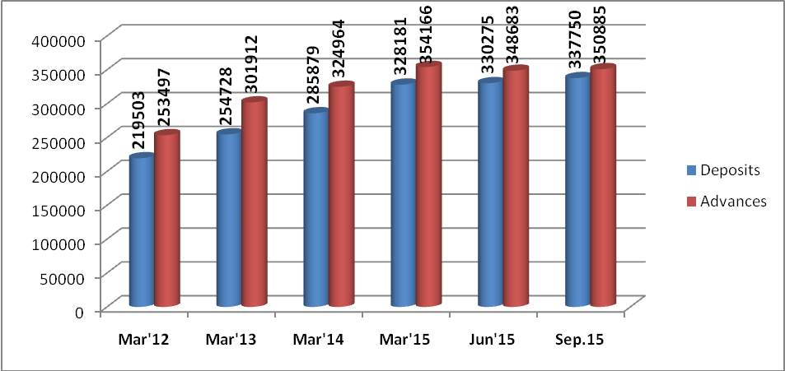

  - Statement of Priority Sector Advances (Outstanding) – 30.09.2015 (Rs. In cr)
S.No. | Particulars | Mar'12 | Mar'13 | Mar'14 | Mar'15 | Jun'15 | Sep.15
1 | Short Term Production Loans | 13544.00 | 19704.00 | 25178.00 | 27663.68 | 23834.08 | 31553.05
2 | Agri. Term Loans including allied activities | 22929.00 | 27140.00 | 24386.00 | 23604.05 | 27341.59 | 20549.85
3 | Total Agriculture Advances | 36473.00 | 46844.00 | 49564.00 | 51267.73 | 51175.67 | 52102.90
4 | % of Agri. Advances to Total Advances | 14.39% | 15.52% | 15.25% | 14.48% | 14.68% | 14.85%
5 | Non-Farm Sector / Micro & Small Enterprises | 17391.00 | 22589.00 | 29301.00 | 33558.74 | 38491.11 | 35837.48
6 | % of Non-Farm Sector / Micro & Small Enterprises to total advances | 6.86% | 7.48% | 9.02% | 9.48% | 11.04% | 10.21%
7 | Export credit |  |  |  |  |  | 100.69
8 | Others' under Priority Sector Advances | 23358.00 | 26957.00 | 23752.00 | 26576.43 | 25888.92 | 27533.81
9 | % of ‘Other’ under Priority Sector advances to total advances | 9.21% | 8.93% | 7.31% | 7.50% | 7.42% | 7.85%
10 | Total Priority Sector Advances | 77222.00 | 96390.00 | 102617.00 | 111402.90 | 115702.11 | 115574.88
10 | % of Priority Sector Advances to total advances | 30.46% | 31.93% | 31.58% | 31.46% | 33.18% | 32.94%
Note : Percentage calculated on total Advances (due to non-availability of ANBC & Net Bank Credit)

Comparative position of Short Term Agriculture Credit: (Rs. In crore)

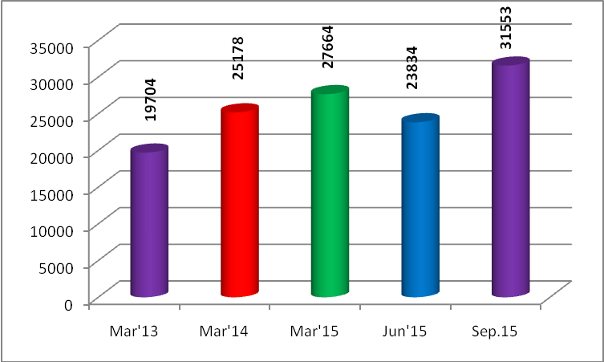

Comparative position of Total Agriculture Credit: (Rs. In crore)

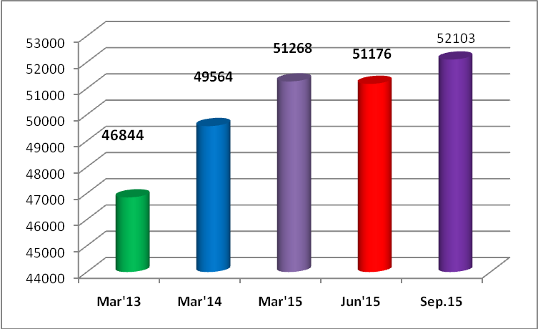
Comparative position of MSE Advances (Rs. In crore)
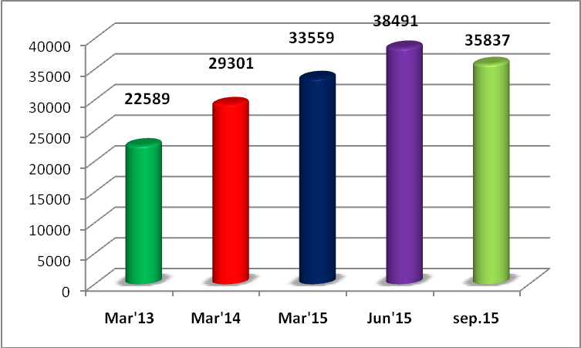
Comparative position of Priority sector lendings (Rs. In crore)
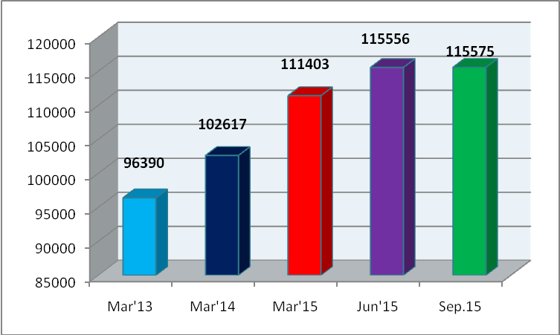
- Bank-wise position on Deposits; Advances & CD Ratio is enclosed as Annexure 3.
- District-wise position on Deposits, Advances & Credit Deposit Ratio is enclosed as Annexure 4.
- Bank-wise position on Priority Sector Advances is enclosed as Annexure 5.
- District-wise position on Priority Sector Advances is enclosed as Annexure 6.
Agenda: 3
Achievement of Annual Credit Plan 2015-16
  - Achievement as on 30.09.2015 (Rs. In cr)

S.No. | Particulars | Achieve-ments upto June.14 | Achieve-ments upto Mar.15 | Target 2015-16 | Achieve-ments upto Jun.15 | Achieve-ments upto Sep.15 | % of achieve-ment during the quarter | % of achieve-ment upto the quarter
1 | Short Term Production Loans
a | Kharif | 4223.49 | 7816.84 | 18092.68 | 6029.30 | 12938.74 | 38.19% | 71.51%
b | Rabi | 0.00 | 10603.04 | 9707.48 | 0.00 | 0.00 | 0.00% | 0.00%
 | Total | 4223.49 | 18419.88 | 27800.16 | 6029.30 | 12938.74 | 24.85% | 46.54%
2 | Agriculture Term Loans | 2241.35 | 2878.97 | 7494.30 | 1774.74 | 3181.86 | 18.78% | 42.46%
3 | Allied to Agriculture | 1767.32 | 5977.31 | 2357.78 | 547.38 | 784.00 | 10.04% | 33.25%
4 | Total Agriculture | 8232.16 | 27276.16 | 37652.24 | 8351.42 | 16904.60 | 22.72% | 44.90%
5 | Micro &small, Medium Enterprises | 6024.03 | 13330.13 | 11020.26 | 7567.12 | 9239.66 | 15.18% | 83.84%
6 | Others' under priority Sector Advances | 1557.97 | 7640.96 | 8647.73 | 1587.03 | 3011.08 | 16.47% | 34.82%
 | Of which
a | Education Loans | 90.18 | 543.05 | 864.32 | 160.18 | 419.03 | 29.95% | 48.48%
b | Housing Loans | 496.77 | 5591.70 | 2306.57 | 798.83 | 1342.46 | 23.57% | 58.20%
c | Others | 971.02 | 1506.21 | 5476.84 | 628.02 | 1249.59 | 11.35% | 22.82%
7 | Export Credit |  |  |  | 26.95 | 13.50
8 | Total Priority Sector Advances | 15814.16 | 48247.25 | 57320.23 | 17532.52 | 29168.84 | 20.30% | 50.89%
9 | Non-Priority Sector Advances | 20796.97 | 65304.41 | 21456.14 | 31509.56 | 44158.27 | 58.95% | 205.81%
10 | Total Credit Plan | 36611.13 | 113551.66 | 78776.37 | 49042.08 | 73327.11 | 30.83% | 93.08%

Banks Performance during the year up to 30/09/15 –
Achievement vis-à-vis targets
- Banks disbursed priority sector loans of Rs. 29168.84 cr. and achieved 50.89% of annual targets.
- Short term production loans amount to Rs. 12938.74 cr. were disbursed and 71.51% of targets under Kharif achieved.
- Term loans to agriculture and allied activities were disbursed to the extent of Rs.3965.86 cr. and achieved 40% of targets.
- MSME loans / advances amounting to Rs. 9239.66 cr. were disbursed and achieved 83.84% of annual targets.
- Education loans of Rs. 419.03 cr. disbursed and achieved 48.48% of annual targets.
- Housing loans of Rs. 1342.46 cr. disbursed and achieved 58.20% of targets.
- Rs. 7271 cr. disbursed to borrowers belonging to weaker sections.
- Rs. 1275.11 cr. disbursed to borrowers belonging to Minority communities.
- Rs. 2367.34 cr. disbursed to borrowers belonging to SC/ST community.
- Rs.5917.61 cr. disbursed to women beneficiaries.

- Bank-wise agriculture advances (Direct & Indirect) – Annexure 7.
- District-wise agriculture advances (Direct & Indirect) – Annexure 8.
- Annual Credit Plan 2015-16 : Bank-wise achievement of target under Agriculture advances is enclosed as Annexure 9.
- Annual Credit Plan 2015-16 :Bank-wise achievement of target under MSE & Priority Sector advances is enclosed as Annexure 10.
- Annual Credit Plan 2015-16 : District-wise achievement of target under Agriculture advances is enclosed as Annexure 11.
- Annual Credit Plan 2015-16 : District-wise achievement of target under MSE & Priority Sector Advances is enclosed as Annexure 12.
Agenda : 4:
Agriculture sector
  - Progress in lending short term production loans:
- As against the Kharif disbursal target of Rs.18092.68 cr for the financial year 2015-16, banks together have disbursed Rs.12938.74 cr, recording an achievement of 71.51%.
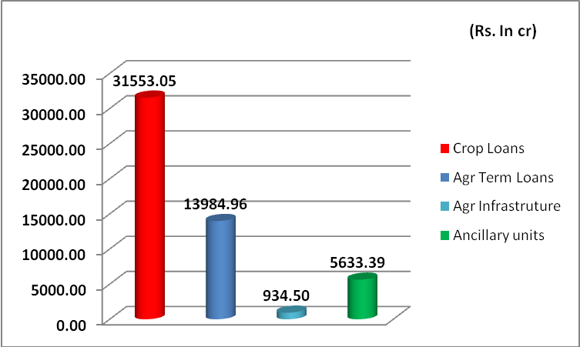

4.2. Vaddileni Runalu and Pavala Vaddi Scheme on Crop Loans
for Kharif & Rabi – 2014-15:

Govt. Of Telangana has issued G.O.Rt.NO. 323 dated 4th July 2015 extending the VLR / Pavala Vaddi Scheme on crop loans for Kharif & Rabi 2014-15. SLBC has circulated the same to member banks and LDMs on 8th July 2015. GOs are enclosed as Annexure no. 59.

4.3 Union Budget 2015-16: Interest subvention Scheme for short term crop loans during the year 2015-16 –RBI Circular No. RBI/2015-16/152 FIDD No. FSD.BC 59/05.04.02/2015-16 dated 13th August 2015.

Govt. of India has approved the implementation of the Interest Subvention Scheme for the year 2015-16 for short term loans upto Rs. 3 lac with the following stipulations. (RBI circular enclosed as Annexure no. 60.)
- Interest subvention @ 2% per annum will be made available to the public sector banks and the private sector banks (in respect of loans given by their rural and semi-urban branches) on their own funds used for short term crop loans up to Rs. 3.00 lac per farmer provided the lending institutions make available short term credit at the ground level at 7% per annum to the farmers. This 2% interest subvention will be calculated on the crop loan amount from the date of its disbursement / drawal up to the date of actual repayment of the crop loan by the farmer or up to the due date of the loan fixed by the banks whichever is earlier, subject to a maximum period of one year.
- Additional interest subvention @ 3% per annum will be available to the farmer repaying the loan promptly from the date of disbursement of the crop loan up to the actual date of repayment or up to the due date fixed by the banks for repayment of crop loan, whichever is earlier, subject to a maximum period of one year from the date of disbursement. This also implies that the farmers payment promptly would get short term crop loans @ 4% per annum during the year 2015-16.

- In order to discourage distress sale by farmers to encourage them to store their produce in warehouse against warehouse receipts, the benefit of interest subvention will be available to small and marginal farmers having Kisas Credit Card for a further period of six months post-harvest on the same rate as available to crop loan against negotiable warehouse receipts for keeping their produce in warehouses.
- To provide relief to farmers affected by natural calamities, the interest subvention of 2% will continue to be available to banks for the first year on the restructured amount. Such restructured loans may attract normal rate of interest from the second year onwards as per the policy laid down by the RBI.
4.4 NAIS - Cut off dates for payment of Insurance Premium for all notified crops by the Non-Loanee farmers:
Govt. Of Telangana has advised guidelines to cover non-loanee farmers under NAIS scheme vide letter no. Crop.Ins(2)/23/2015 dated 27th July 2015, and the cut off dates for payment of premium by the non-loanee farmers under National Agriculture Insurance Scheme is upto 31st July 2015 for all notified crops during Kharif 2015 season. (The same has been circulated by SLBC to the member banks on29th July 2016). Subsequently, the cut off date has been extended to 15th September 2015 by Govt. Of Telangana vide G.O. Rt. No. 417 dated 8th September 2015. SLBC has communicated the same to banks. GO enclosed as Annexure 67.
4.5 Target for financing of JLGs during 2015-16:
As advised by NABARD, bank-wise / district-wise JLG targets are allocated. Financing of JLGs under non-farm sector activities will continue, over and above the allotted target. Despite repeated reminders monthly progress report is not being submitted by many banks. Banks are requested to submit the report to have a meaningful review of performance. Annexure 45.

4.6 Indira Kranthi Patham – Target for 2015-16
Govt. Of Telangana has allocated the target for the year 2015-16 under Indira Kranthi Patham. The same have been sent on 27th July 2015 to all banks / Lead District Managers for allocating the same to the branches. Bank-wise targets are enclosed as Annexure no. 61
4.7 Poultry Farming– Reschedulement of loans on account of BirdFlu:
Reserve Bank of India vide cir.no. FIDD(H)/LBS/175/02.02.020/2014-15 dated the 31st August 2015 advised that granting a moratorium on repayment of interest and / or instalment on term loans availed by the borrowers in the poultry industry is a commercial decision to be taken by banks. However, any alteration of repayment period / repayable amount / the amount of instalments / rate of interest (due to reason other than competitive reasons) would amount to restructuring of loans. The latest DBR guidelines for restructuring under Part B of the master circular on prudential norms on Income Recognition, Asset Classification and Provisioning will be applicable for such restructured loans. Thus, banks would be free to restructure and extend the repayment period of loans to any category of borrower which comes under stress. However, RBI is not in favour of extending any asset classification benefits beyond what is already provided in the extant restructuring guidelines for any particular sector or segment. (The circular has been sent to member banks on 30th Sep., 2015). The RBI circular is annexed as Annexure no. 62.

4.8 Pledge financing against Negotiable Warehouse receipts (NWRs):
RBI has advised the banks to furnish quarterly data (district-wise) on pledge financing against Negotiable Warehouse Receipts (NWRs) to farmers within 20 days from the end of each quarter from Sept., 2015 onwards. All the controlling authorities of banks are requested to submit the information in the format already communicated.

Data on Negotiable Warehouse Receipts.
S.No. | Name of the Bank | No. of A/c. | Amount outstanding
 | PUBLIC SECTOR BANKS | 521 | 3115.15
1 | ALLAHABAD BANK
2 | ANDHRA BANK | 0 | 0.00
3 | BANK OF BARODA
4 | BANK OF INDIA | 0 | 0.00
5 | BANK OF MAHARASHTRA | 0 | 0.00
6 | BHARATIYA MAHILA BANK
7 | CANARA BANK
8 | CENTRAL BANK OF INDIA | 0 | 0.00
9 | CORPORATION BANK
10 | DENA BANK
11 | IDBI BANK | 51 | 330.66
12 | INDIAN BANK
13 | INDIAN OVERSEAS BANK
14 | ORIENTAL BANK OF COMMERCE | 0 | 0.00
15 | PUNJAB NATIONAL BANK | 40 | 522.95
16 | PUNJAB & SIND BANK
17 | SYNDICATE BANK
18 | UCO BANK | 0 | 0.00
19 | UNION BANK OF INDIA
20 | UNITED BANK OF INDIA
21 | VIJAYA BANK
22 | STATE BANK OF BIKANER & JAIPUR | 0 | 0.00
23 | STATE BANK OF HYDERABAD | 430 | 2261.54
24 | STATE BANK OF INDIA | 0 | 0.00
25 | STATE BANK OF MYSORE
26 | STATE BANK OF PATIALA | 0 | 0.00
27 | STATE BANK OF TRAVANCORE
 | PRIVATE SECTOR BANKS | 85 | 626.16
28 | AXIS BANK | 37 | 29.67
29 | CATHOLIC SYRIAN BANK'
30 | CITY UNION BANK
31 | DEVELOPMENT CREIDT BANK
32 | DHANALAXMI BANK
33 | FEDERAL BANK | 0 | 0.00
34 | HDFC BANK
35 | ICICI BANK | 4 | 10.90
36 | INDUSIND BANK | 0 | 0.00
37 | JAMMU & KASHMIRBANK
28 | KARNATAKA BANK
39 | KARUR VYSYA BANK
40 | KBSLAB | 0 | 0.00
41 | KOTAK MAHINDRA BANK
42 | LAKSHMI VILAS BANK | 44 | 585.59
43 | RATNAKAR BANK | 0 | 0.00
44 | SOUTH INDIAN BANK | 0 | 0.00
45 | TAMILNADU MERCANTILE BANK
46 | YES BANK
 | CO.OP BANKS | 23 | 52.45
47 | TS Co-op Apex Bank | 21 | 49.00
48 | AP MAHESH CO.OP BANK | 2 | 3.45
 | REGIONAL RURAL BANKS | 0 | 0.00
49 | AP GRAMEENA VIKAS BANK
50 | TELANGANA GRAMEENA BANK
 | GRAND TOTAL | 629 | 3793.76
4.9 Agri-Clinics & Agri-Business Centres (ACABC) – Review of progress:
The Central Scheme “Establishment of Agri-Clinics & Agri-Business Centers (ACABC)” launched in April, 2002 and has created wide awareness and motivation about the potential of agri preneurship in rural areas among all the stakeholders. The Agri ventures setup under ACABC scheme are expected to necessarily provide advisory and extension services also to the farmers and this supplement the efforts of public extension system including unemployed candidates in rural areas.

National Institute of Agricultural Extension Management (MANAGE) is implementing training component of the Scheme through Nodal Training Institutes identified across the country and NABARD is the responsible for disbursement of subsidy to trained candidates availing bank finance for establishing their agri-ventures.

NABARD vide Ref.No.NB.T & AP RO.HYD/DoR/8120/ICD-72/2014-15 dated 16.02.2015 informed that
- Large number of proposals are pending with various banks since 2010
- Proposals which are sanctioned by banks under ACABC but, subsidy claims to that extent have not been received by NABARD.

NABARD has requested the banks to look into the pendency of the proposals at bank / branch level and advise the concerned branches for processing loan applications as per scheme guidelines and the status may be intimated to NABARD RO with a copy to SLBC.

All Banks are requested that necessary instructions may be issued to their branches to expedite the clearance of pending loan applications under ACABC scheme and also releasing bank finance to the trained candidates on priority.

As regards the proposals already sanctioned by bank branches under ACABC, it is advised to submit subsidy claims, in the prescribed format to NABARD, RO, so that the benefit of subsidy can be passed on to the agripreneur.
(Rs. In cr)
Period | Outstanding |  | Disbursement during the period (01/04/15 to 30/09/15)
Period | No. | Amount | No. | Amount
Sep’15 | 754 | 61.58 | 82 | 3.55
- During the year upto Sept., 2015, an amount of Rs. 3.55 cr has been disbursed by banks to 82 beneficiaries.

4.10 Dairy Entrepreneurship Development Scheme (DEDS) – Continuation of the scheme for the financial year 2015-16

NABARD vide Ref. NB (DoR)/GSS/338/DEDS 4/2015-16 dated 30.04.2015, Circular No.81/DoR23/2015 informed that the budget provision of Rs.127 cr has been made for 2015-16 which include Rs.99 cr. under General/ST component. This amount is just sufficient to clear the pending claims at NABARD level. However, sufficient funds are available under SC and NES Category. Therefore, banks are advised to focus on lending for SC beneficiaries and beneficiaries under NER states.

Department of Financial Services, Ministry of Finance, GoI vide Lr. No.F.No.3/13/2011-AC, dated 14 November, 2013 informed that the Department of Animal Husbandry, Dairying & Fisheries, Ministry of Agriculture, GoI has directed to review the progress made under Dairy Entrepreneurship Development Scheme (DEDS) may be taken up as a regular agenda item in the DCC/DLRC meetings at District level. LDMs are requested to make a note of it.
(Rs. In cr)
Period | Outstanding |  | Disbursement during the period (01/04/15 to 30/09/15)
Period | No. | Amount | No. | Amount
Sep’15 | 19421 | 203.99 | 719 | 7.55
- During the year upto Sep., 2015, an amount of Rs. 7.55 cr has been disbursed by banks to 719 beneficiaries.
4.11 Overdues / NPAs under Agriculture sector as on 30.09.2015 (Rs. In cr)
 |  | Outstanding as on 30.09.2015 |  | Overdues (*) as on 30.09.2015 |  |  | NPAs as on 30.09.2015
 |  | No.of a/cs. | Amount | No.of a/cs. | Total Balance in overdue a/cs. | Actual overdue amount | No.of a/cs. | Amount
1 | Short Term Crop Production Loans | 4450623 | 31553.05 | 573287 | 5754.75 | 3370.76 | 186373 | 1730.27
2 | Agri. Term Loans | 842445 | 13984.96 | 189946 | 3392.48 | 1698.04 | 99652 | 1332.78
3 | Agri. Infrastructure | 10275 | 934.50 | 991 | 175.43 | 75.67 | 761 | 28.34
4 | Ancillary activities | 135373 | 5633.39 | 6581 | 1370.94 | 608.45 | 4662 | 474.82
3 | Total Agriculture | 5438716 | 52102.91 | 770805 | 10693.61 | 5752.92 | 291448 | 3566.22

Outstanding balances in Agriculture segment as at the end of Sept., 2015

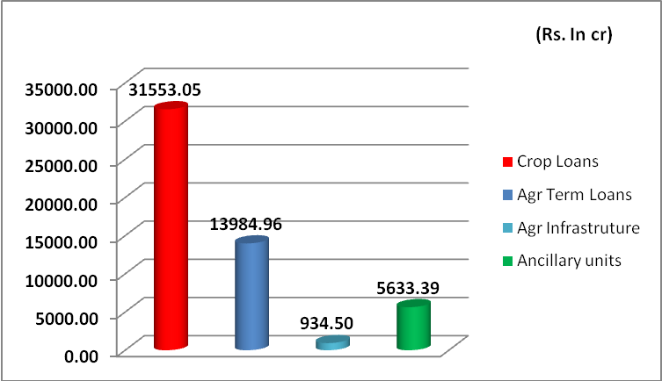

Over-dues in Agriculture segment as at the end of Sept., 2015

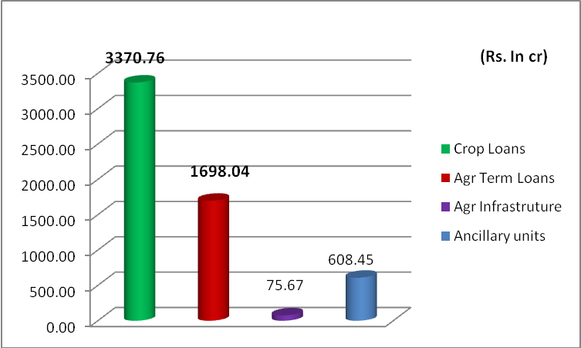

NPAs in agriculture segment as at the end of Sept. 2015

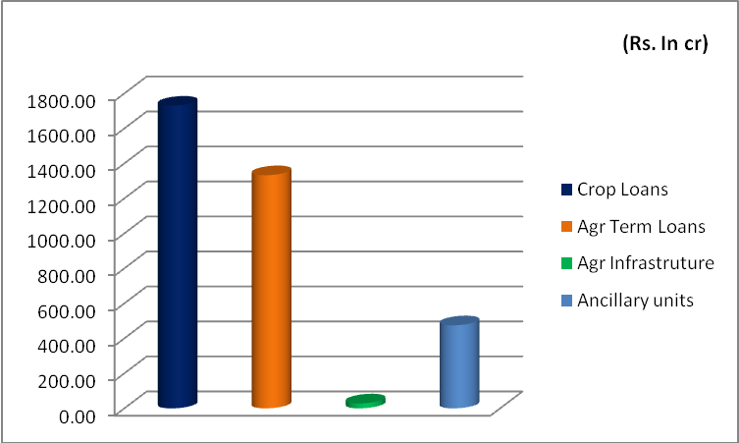
- The level of NPAs as on 30/09/2015 when compared to 30.06.2015 decreased by Rs.804.53 cr.
- 5.48% of short term crop loans out of outstanding of Rs. 31553.05 cr. are NPAs in the books of the banks.
- 8.93% of Agriculture Term Loans (including allied activities, infrastructure and ancillary activities) out of outstandings of Rs. 20549.86 cr. are NPAs in books of the banks.
- NPAs in total agriculture advances are at 6.84%.
- Short Term Crop Loan Production Loans – Bank-wise position on overdue position is enclosed as Annexure 32.
- Agriculture Term Loans including Allied Activities – Bank-wise position on overdue position is enclosed as Annexure 33.
- Indirect Agriculture Term Loans including Allied Activities – Bank-wise position on overdue position is enclosed as Annexure 34.
- Total Agriculture Advances – Bank-wise position on overdue position is enclosed as Annexure 35.

Agenda: 5:
5.1 Micro, Small & Medium Enterprises (MSME) Sector
(Priority & Non-priority) (Rs. In cr)

S.No. | Particulars | Outstanding as on 31.03.2015 |  | Outstanding as on 31.06.2015 |  | Outstanding as on 30.09.2015
S.No. | Particulars | A/c. | Amt. | A/c. | Amt. | A/c. | Amt.
1 | Micro Enterprises | 534143 | 18865.40 | 479717 | 24186.85 | 541027 | 24047.86
2 | Small Enterprises | 153394 | 22317.50 | 152387 | 36904.09 | 171985 | 42219.37
3 | Total SME | 687537 | 41182.90 | 632104 | 61090.94 | 713012 | 66267.23
4 | % of Micro enterprises to total MSE | 77.69% | 45.81% | 75.89% | 39.59% | 75.88% | 36.29%
5 | % of Small enterprises to total MSE | 22.31% | 54.19% | 24.11% | 60.41% | 24.12% | 63.71%
6 | Medium Enterprises | 93717 | 10161.48 | 124917 | 12831.64 | 97507 | 14031.43
7 | % of Medium enterprises to total MSME advances | 12.00% | 19.79% | 16.50% | 17.36% | 12.03% | 17.47%
8 | Total MSME advances | 781254 | 51344.38 | 757021 | 73922.58 | 810519 | 80298.66
The large growth in MSME segment due to reclassification of priority sector advances & others as per RBI circular.
(Rs. In cr)
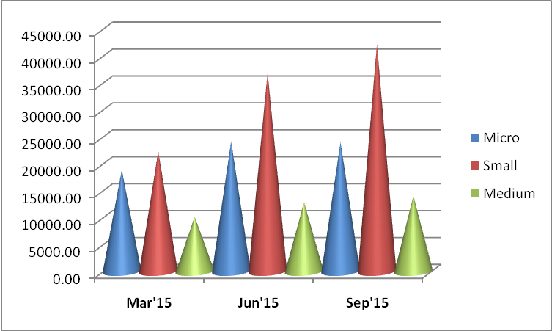

- During the quarter, advances to MSE sector grew by Rs.5176.29 cr and stood at Rs. 66267.23 cr as at the end of Sept., 2015.
- During the year, Advances to Micro enterprises and Small Enterprises registered a growth Rs.5182.46 cr and Rs. 19901.87 cr respectively.
- During the quarter under review, Small Enterprises grew by Rs. 5315.28cr whereas Micro Enterprises declined by Rs. 138.99 cr.
- Advances to Medium Enterprises registered a growth of Rs.1199.79 cr during the quarter and by Rs. 3869.95 cr during the year 2015-16.
- MSME segment grew by Rs. 6376.08 cr during the quarter, and by Rs. 28954.28 cr during the year 2015-16.
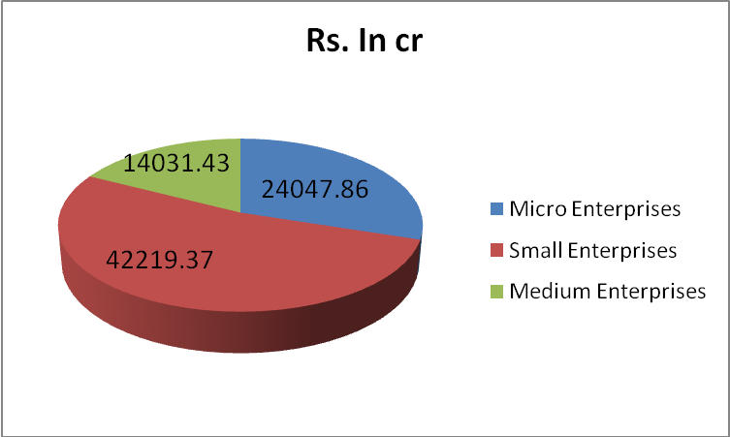

5.2 Overdue/NPAs under MSME Sector as on 30.09.2015 (Rs. In cr.)
S. No. | Particu-lars | Outstanding |  | Overdues |  |  | NPAs
S. No. | Particu-lars | A/c. | Amt | No. of overdue A/c. | Total Balance in overdue accounts | Actual overdue amount | No. of A/c. | Amount
1 | Micro | 541027 | 24047.86 | 124288 | 3768.20 | 2115.56 | 75185 | 1567.92 (6.52%)
2 | Small | 171985 | 42219.37 | 15615 | 4717.79 | 2924.27 | 6103 | 1926.43  (4.56%)
3 | Total MSE | 713012 | 66267.23 | 139903 | 8485.99 | 5039.83 | 81288 | 3494.33 (5.27%)
4 | Medium | 97507 | 14031.43 | 1189 | 2843.27 | 1626.31 | 754 | 1912.80 (13.63%)
3 | Total MSME | 810519 | 80298.66 | 141092 | 11329.26 | 6666.14 | 82042 | 5407.13 (6.73%)
Position of NPAs under MSME sector as at the end of Sept., 015
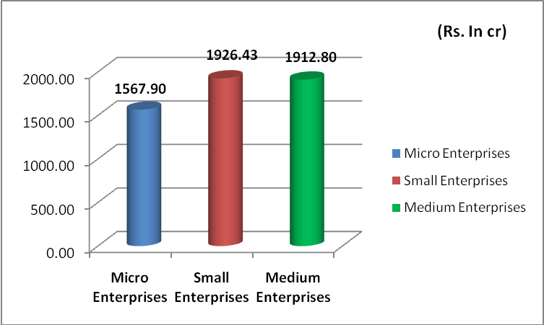
Position of overdues under MSME sector as at the end of Sept., 2015
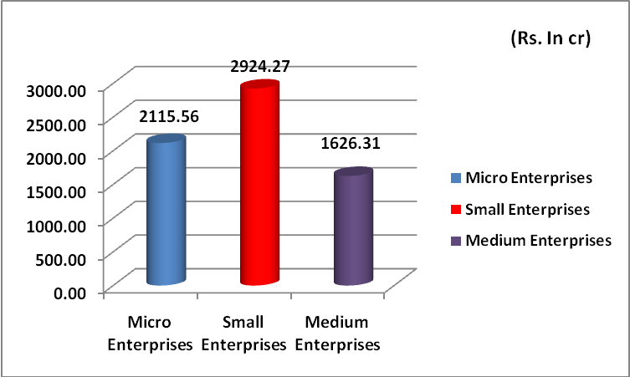
- Overdues under the Micro enterprises segment at Rs.2115.56 cr. constitute 8.80% of outstandings MSE advances
- NPAs under Micro enterprises are at 6.52% of outstandings.
- Under Small enterprises, overdue amount of Rs. 2924.27 cr. constitute 6.95% of total outstandings of MSE.
- NPA under Small enterprises are at 4.56% of outstadings..
- Overdues under Medium enterprises at Rs.1626.31 cr. constitute 11.59% of outstandings.
- NPAs under Medium enterprises constitute 13.63% of total outstandings which is more than the NPAs of MSME segment which is at 6.73%
- Bank-wise position on Micro; Small & Medium Enterprises (MSME) advances is enclosed as Annexure 13.
- Micro & Small Enterprises – Bank Wise position of overdue / NPAs is enclosed as Annexure 36.
  - PMEGP Targets for the year 2015-16:
The Khadi and Village Industries Commission (KVIC) has allocated district-wise targets for the year 2015-16 in the State of Telangana. The same have been advised to LDMs. Targets enclosed as Annexure 63.
5.4 Pradhan Manthri Mudra Yojana (PMMY):
Mudra Campaign was launched in the state by the Hon’ble Union Ministers Sri Venkaiah Naidu and Sri Bandaru Dattatreya on the 25th Sept., 2015 in Hyderabad.

Organizing Credit Campaigns: Department of Financial Services, MoF, GoI has directed all banks to organize Mega Credit Campaings for disbursement of loans under ‘Shishu’ Category during 25th September, 2015 to 2nd October.

Telangana State – Enrolment camps in Town Halls / Centres for APY, PMMY/MUDRA & PMJJBY and PMSBY
Date | Centre | Bank
13/07/15 | Adilabad | Telangana Grameena Bank
13/07/15 | Nizamabad | State Bank of Hyderabad
13/07/15 | Karimnagar | Andhra Bank
14/07/15 | Jagtial | State Bank of Hyderabad
16/07/15 | Ramagundam | Indian Bank
13/07/15 | Sangareddy | State Bank of India
14/07/15 | Siddipeta | State Bank of Hyderabad
13/07/15 | Nalgonda | State Bank of Hyderabad
14/07/15 | Miryalguda | Andhra Bank
16/07/15 | Suryapeta | State Bank of India
13/07/15 | Mahabubnagar | State Bank of India
13/07/15 | Warangal | Canara Bank
13/07/15 | Khammam | Andhra Bank
15/07/15 & 16/07/15 | GHMC, Hyderabad
16/07/15 & 17/07/15 | Secunderabad

Controllers of the banks are advised to:
- Contact all Government Agencies and organizations which are involved in technical and entrepreneurship training such as RSETIs / RUDSETIs / Jan Shikshan Sansthans / MSME – Development Institutes (DIs) etc. and obtain list of trained candidates for the last one to two years and share the information to the banks in the district for extending finance to eligible candidates.
- Make efforts to contact the training organizations of other Ministers of Central and State Governments operating in the district for obtaining the list of trained candidates and share with banks for extending the finance to eligible candidates.
- Initiate general steps for publicity in local print and electronic media, through hoardings, banners, flyers and organizing special campaigns etc.
- Sensitize the branches in extending overdraft facility in PMJDY accounts as per the eligibility.
- Branches should make preparations such as availability of sufficient number of applications, publicity materials, finding the potential borrowers, collecting application forms and processing of loan application etc.
Pradhan Mantri MUDRA Yojana
S.No | Category | No. of Branches in the State | Target (Rs. In cr)
1 | PSBs | 3109 | 4116.04
2 | Pvt. Sector Banks | 732 | 299.59
3 | RRBs | 804 | 141.42
Total |  | 4645 | 4557.05

Local language Application for Pradhan Mantri MUDRA Yojana – for ‘Shishu’ category is placed as Annexure no.64. Local language Application for Pradhan Mantri MUDRA Yojana (Kishore & Tarun category) is placed as Annexure.No. 65. These are also made available in SLBC web-site i.e., www. Slbctelangana.com. Bank-wise PMMY targets are enclosed as Annexure no.66

5.5 Streamlining flow of credit to Micro and Small Enterprises (MSEs) for facilitating timely and adequate credit flow during their ‘Life Cycle’

RBI vide circular no. RBI/2015-16/160, FIDD.MSE & NFS.BC.No. 60/06.02.31/2015-16 dated 27th August 2015 issued guideliens on streamlining flow of credit to Micro and Small Enterprises (MSEs) for facilitating timely and adequate credit flow during their ‘Life Cycle’ wherein it was informed that Micro and Small units are more prone to facing financial difficulties during their life cycle than large enterprises / corporate when the business conditions turn adverse. Absence of timely support at such a juncture could lead to the unit turning sick and many a time irreversibly. As such, role of banks in providing continuous support to viable MSEs during such phases of transient financial difficulties assumes significance.

Accordingly, banks have been advised to put up in place ‘board approved policy on lending to MSEs’ adopting an appropriate system of timely and adequate credit delivery to borrowers in the MSE segment within the broad prudential regulations of Reserve Bank of India.
5.6 CGTMSE Scheme – Progress made by banks during the year upto 30/09/2015
District wise Guarantee approved accounts for the State of Telangana
for the quarter ended 30th Sept. 2015
SNo. | District Name | Proposals  June 2015 | Approved Amt  June 2015 | Proposals  Sept.15 | Approved Amt  Sept.15
1 | ADILABAD | 130 | 252.99 | 83 | 255.34
2 | HYDERABAD | 543 | 5686.41 | 509 | 4717.41
3 | KARIMNAGAR | 67 | 268.39 | 99 | 146.17
4 | KHAMMAM | 57 | 281.39 | 46 | 325.62
5 | MAHBUBNAGAR | 202 | 239.47 | 99 | 232.17
6 | MEDAK | 58 | 296.76 | 92 | 218.32
7 | NALGONDA | 125 | 482.45 | 135 | 397.59
8 | NIZAMABAD | 88 | 450.48 | 82 | 302.34
9 | RANGAREDDY | 548 | 4231.66 | 829 | 4307.03
10 | WARANGAL | 129 | 1439.03 | 152 | 529.66
 | TOTAL | 1947 | 13626.03 | 2126 | 11431.65
As per the study conducted by Reserve Bank of India, there is a knowledge gap observed amongst the entrepreneurs and the banks and emphasizd on the need to create more awareness on CGTMSE. The Controlling Authorities of all Banks in Telangana states are advised to:
- Sensitize the Branch Managers to extend coverage of all new eligible micro & small units under the scheme.
- Display at bank branches on the availability of collateral free loans.
- All loan applications are to be acknowledged.
- Banks shall have monitorable action plan as suggested by Reserve Bank of India.
The performance on coverage under the scheme is 2126 units as at the end of Sept., 2015. Banks are advised to ensure that all new eligible Micro & Small units are covered in the scheme to achieve the set targets for the year 2015-16.
5.7 Specialized MSME branches in the state of Telangana:
SLBC has received data from banks that 101 specialized MSME branches are operating in the state as on 25th August 2015. Bank may explore the possibility of opening more specialized MSME branches in the state.
5.8 Rehabilitation of Sick Micro & Small Enterprises:
The feedback received by Reserve Bank of India at various for a on MSEs and analysis shows that the identification of sickness in MSE enterprises is so late that the possibilities of revival recede. This necessitates a need for change in the definition of sickness in order to remove the delay factor.
The emphasis of the revised guidelines is to hasten the process of identification of a unit as sick, early detection of incipient sickness, and to lay down a procedure to be adopted by banks before declaring a unit as unviable. Accordingly, the revised guidelines are issued for rehabilitation of sick units in the MSE sector as given in Annexure I of Cir. No. RBI/2012-13/273, RPCD.CO. MSME & NFS.BC. 40/06.02.31/2012-13, dated the 1st November 2012.
The important changes brought out in the guidelines based on the recommendations of the working group vis-à-vis the existing guidelines on rehabilitation of sick MSE units are furnished in Annexure II of the above circular.
Reserve Bank of India emphasizes that timely and adequate credit to potentially viable MSE units which have already become sick or are likely to become sick is of utmost importance not only from the point of view of the financing banks but also the improvement of the national economy, in view of the sector’s contribution to the overall industrial production, exports and employment generation.
The banks should therefore, take a sympathetic attitude and strive for rehabilitation, in respect of units in the MSE sector, particularly wherever the sickness is on account of circumstances beyond the control of the entrepreneurs. However, in cases of units, which are not capable of revival, banks should make efforts for a settlement and/or resort to other recovery measures, expeditiously.
5.9 Review of Revival of Sick MSE units at District level:
RBI has advised banks to furnish the following information to enable an appropriate environment for monitoring timely credit needs of MSMEs

a. The District wise credit flow as well as NPA data to MSE sector.
b. The banks efforts in nursing and rehabilitation of sick units in the district.

RBI also advised that these issues are to be taken up in the DCC / DLRC meetings hereafter and developments may be reported by banks to RBI in time. RBI stated that the guidelines on rehabilitation of sick units should be followed strictly by banks and the efforts should be made by banks to rehabilitate incipient sick and potentially viable units.

Hence, all Lead District Managers are advised to take note of the same and ensure that these issues are discussed in DCC / DLRC meetings.
5.10 Implementation of Modified REMOT scheme renamed as ‘Coir Udyami Yojana (CUY)’
Coir Board, Ministry of MSME, Government of India vide Lr. No. CB/REMOT/2012-13/35/1-Vo.II dated 28.01.2015 informed that the Central Sector Scheme of Rejuvenation, Modernization and Technology Up gradation (REMOT) has been renamed as “Coir Udyami Yojana” (CUY) so as to convey the objectives of the scheme properly to general public.
The Coir Udyami Yojana is one of the schemes under the Ministry of MSME which aims at the creation of new entrepreneurs, employment generations, poverty alleviation and enhancement in the income and living conditions of the coir workers. Hence, special attention / support have to be given for effective implementation of the scheme.
Controlling authorities of all banks are requested to give necessary directions to the branches to sanction loans for all the eligible borrowers under Coir Udyami Yojana for the year 2015-16.

5.11 Non-adherence to RBI guidelines on security / co-obligation and keeping register for Rejected loans for recording the reasons:

RBI has informed that banks are not maintaining registers/electronic records at the branches to record the date of receipt, sanction/rejection/disbursement with reasons thereof etc. of applications as instructed vide RBI circular RPCD.CO.BC 10/04.09.01/2014-15 dated July 01, 2014. RBI advised that all banks to strictly adhere to the guidelines issued by them in this regard.

SLBC circulated these guidelines to controlling authorities of all banks for strict compliance.
5.12 Implementation of PMEGP: (Rs. In lac)
Sr. No | Agency | TARGET-2015-16 |  |  | Sanctioned by Banks |  | Achievement-2015-16
Sr. No | Agency | No.of Projects | Margin Money | Emp. (Nos) | No.of Projects | Margin Money | No.of Projects | Margin Money | Empl. (Nos)
1 | KVIC SO Hyd. | 239 | 478.20 | 1913 | 98 | 451.22 | 88 | 414.51 | 1451
2 | KVIB | 239 | 478.20 | 1913 | 145 | 675.41 | 111 | 462.32 | 1618
3 | DIC | 319 | 637.60 | 2550 | 291 | 967.80 | 164 | 413.30 | 1446
 | TOTAL | 797 | 1594.00 | 6376 | 534 | 2094.43 | 363 | 1290.13 | 4515
During the year 2015-16, the achievement in no. of projects is 363 with an amount of Rs. 1290.13 lac against a target of Rs. 797 projects with an outlay of Rs.1594.00 lac.
Agenda: 6:
Housing Loans
  - Position as on 30.09.2015 (under Priority sector) (Rs. In cr)

Period | Outstanding |  | Disbursement during the period (01/04/15 to 30/09/15)
Period | No. | Amount | No. | Amount
Sep’15 | 273369 | 17569.01 | 18772 | 1342.46
- During the year up to Sep., 2015, an amount of Rs. 1342.46 cr has been disbursed by banks to 18772 beneficiaries which is 58.20% of its annual targets.
- Bank wise position as on 30.09.2015 is given in the Annexure 14.
  - Overdue/NPAs under Housing Loans as on 30.09.2015
(Rs. In cr)
S.No. | Particu-lars | Outstanding |  | Overdues |  |  | NPAs
S.No. | Particu-lars | A/c. | Amt | No. of overdue A/c. | Total Balance in overdue a/c. | Actual overdue amount | No.of A/c. | Amount
1 | Housing Loans | 273369 | 17569.01 | 47843 | 2940.50 | 309.79 | 18167 | 450.40 (2.56%)
- Overdue amount under Housing loans at Rs. 309.79 cr constitute 1.76% of total outstandings.
- NPAs constitute 2.56% of the Housing Loans outstanding, at Rs.450.40 cr.
- Bank wise position on overdue / NPAs as on 30.09.2015 is given in the Annexure 42.
Agenda – 7:
Education Loans
  - Position as on 30.09.2015 (under Priority sector) (Rs. In cr)

Period | Outstanding |  | Disbursement during the period (01/04/15 to 30/09/15)
Period | No. | Amount | No. | Amount
Sep’15 | 88016 | 3239.95 | 12181 | 419.03
- During the year, banks have disbursed Rs.419.03 cr under education loans to 12181 students which is 48.48% of the annual targets.
- Bank-wise position as on 30.09.2015 is given in the Annexure 15.
- Bank-wise targets is given in the Annexure 16.
  - Overdue/NPAs under Education Loans as on 30.09.2015
(Rs. In cr)
S.No. | Particu-lars | Outstanding |  | Overdues |  |  | NPAs
S.No. | Particu-lars | A/c. | Amt | No. of overdue A/c. | Total Balance in overdue a/c. | Actual overdue amt. | No.of A/c. | Amount
1 | Education loan | 88016 | 3239.95 | 15612 | 478.22 | 114.01 | 6245 | 131.50 (4.05%)
- The accounts with overdues constitute 17.74% of educational loan accounts and overdues constitute 3.52% of total outstandings.
- NPAs constitute 4.05% of the education loan outstanding, at Rs. 131.50 cr.
- Bank-wise position on overdue . NPAs as on 30.09.2015 is given in the Annexure 41.

7.3 Dr. Ambedkar Central Sector Scheme of Interest Subsidy on Education Loan for Overseas Studies for Other Backward Classes (OBCs) (Effective from 2014-15):

The scheme of Interest Subsidy on educational loans for overseas studies will promote educational advancement of student from Other Backward Classes. The objective of the scheme is to award interest subsidy to meritorious students belonging to other weaker sections of the society so as to provide them better opportunities for higher education abroad and enhance their employability.
This is a Central Sector Scheme to provide interest subsidy to the student belonging to the OBCs on the interest payable for the period of moratorium for the Education Loans under the Scheme of Interest subsidy on Educational Loans for Overseas Studies to pursue approved courses of studies abroad at Masters and Ph.D level.
Income Ceiling:
- Total income from all sources of the employed candidate or his/her parents/guardians in case of unemployed candidate shall not exceed Rs.3.00 lakh per annum.
- Under this Scheme, Income certificate produced by the student for availing Educational Loan viz. ITR / Form 16 / Audited Accounts / Income certificate issued by the authority of State Government / UT Administration is acceptable to determining Income ceiling.
- The OBC Caste certificate in the prescribed Proforma issued by the competent authority must be taken by the Banks.

Rate of Interest Subsidy:
- Under the scheme, interest payable by the students availing the education loans of the IBA for the period of moratorium (i.e. course period, plus one year or six months after getting job, whichever is earlier) as prescribed under the Education Loan Scheme of the IBA, shall be borne by the Government of India.
- After the period of moratorium is over, the interest on the outstanding loan amount shall be paid by the student, in accordance with the existing Educational Loan Scheme as may be amended from time to time.
- The candidate will bear the Principal installments and interest beyond moratorium period.

7.4 Dr. Ambedkar Central Sector Scheme of Interest Subsidy on Education Loan for Overseas Studies for Economically Backward Classes (EBCs) (Effective from 2014-15):
The scheme of Interest Subsidy on educational loans for overseas studies will promote educational advancement of student from Economically Backward Classes. The objective of the scheme is to award interest subsidy to meritorious students belonging to economically weaker sections of the society so as to provide them better opportunities for higher education abroad and enhance their employability.
This is a Central Sector Scheme to provide interest subsidy to the student belonging to the EBCs on the interest payable for the period of moratorium for the Education Loans under the Scheme of Interest subsidy on Educational Loans for Overseas Studies to pursue approved courses of studies abroad at Masters and Ph.D level.
Income Ceiling:
- Total income from all sources of the employed candidate or his/her parents/guardians in case of unemployed candidate shall not exceed Rs.1.00 lakh per annum.

- Under this Scheme, Income certificate produced by the student for availing Educational Loan viz. ITR/Form 16/Audited Accounts/Income certificate issued by the authority of State Government/UT Administration is acceptable to Ministry for determining Income ceiling. There is no need to obtain fresh Income certificate from students.
Agenda – 8:
8.1 Credit flow to Minority Communities :
The position of credit to minority communities as on 30.09.2015 is as under:
(Rs. In cr)
Period | Outstanding |  | Disbursement during the period (01/04/15 to 30/09/15)
Period | No. | Amount | No. | Amount
Sep’15 | 739893 | 8960.92 | 85091 | 1275.11
- During the current financial year, banks have financed Rs. 1275.11 cr to 85091 beneficiaries of minority communities.
- During the year, advances extended to minorities is 7.75% of total priority sector advances (RBI norm is 15% on priority sector advances).
- Similarly up to Sept. 2015 loan outstandings to minorities in total advances is at 2.55%.
- Bank wise position as on 30.09.2015 is given in the Annexure 18.
  - Overdue/NPAs under loans to Minorities as on 30.09.2015
(Rs. In cr)
S.No. | Particu-lars | Outstanding |  | Overdues |  |  | NPAs
S.No. | Particu-lars | A/c. | Amt | No. of overdue A/c. | Total Balance in overdue a/c. | Actual overdue amount |  | No.of A/c. | Amount
1 | Loans to Minorities | 739893 | 8960.92 | 193624 | 1824.93 | 1042.60 |  | 84890 | 924.98 (10.32%)
- 11.63% of the loan outstanding to minorities are overdue in the books of the banks and 10.32% of outstandings are NPAs.

Agenda – 9:
9.1 Credit flow to Weaker sections :
The position of credit flow to weaker sections as on 30.09.2015 is as under:
(Rs. In cr)
Period | Outstanding |  | Disbursement during the period (01/04/15 to 30/09/15)
Period | No. | Amount | No. | Amount
Sep’15 | 2942131 | 26804.01 | 1059653 | 7271.11
- During the year up to Sep. 2015 Rs. 7271.11 cr. has been disbursed to 1059653 weaker section beneficiaries.
- Up to Sept. 2015, the advances extended to weaker sections is 7.64% of total advances (RBI norm is 15% on ANBC).
- Bank wise position as on 30.09.2015 is given in the Annexure 19.
  - Overdue/NPAs under loans to Weaker Sections as on 30.09.2015
(Rs. In cr)
S.No. | Particu-lars | Outstanding |  | Overdues |  |  | NPAs
S.No. | Particu-lars | A/c. | Amt | No. of overdue A/c. | Total Balance in overdue a/c. | Actual overdue amount |  | No.of A/c. | Amount
1 | Loans to Weaker Sections | 2942131 | 26804.01 | 453360 | 3640.55 | 1600.82 |  | 224269 | 1483.44 (5.53%)
- 5.97% of the loan outstanding to weaker sections are overdue in the books of the banks whereas 5.53% of outstandings are NPAs.
Agenda – 10:
  - Credit Flow to Scheduled Castes/Scheduled Tribes :

The position of credit flow to SC/STs as on 30.09.2015 is as under: (Rs. In cr)

Period | Outstanding |  | Disbursement during the period (01/04/15 to 30/09/15)
Period | No. | Amount | No. | Amount
Sep’15 | 1196983 | 8123.29 | 425555 | 2367.34
- During the year up to Sep., 2015, banks have extended financial assistance to 425555 borrowers with an outlay of Rs. 2367.34 cr.
- The total loan outstandings to SC/ST beneficiaries constitute 7.02% of Priority sector advances and 2.31% of total advances.
- Bank wise position as on 30.09.2015 is given in the Annexure 20.
  - Overdue/NPAs position to SC/ST beneficiaries as on 30.09.2015:
(Rs. In cr)
S.No. | Particu-lars | Outstanding |  | Overdues |  |  | NPAs
S.No. | Particu-lars | A/c. | Amt | No. of overdue A/c. | Total Balance in overdue a/c. | Actual overdue amount |  | No.of A/c. | Amount
1 | Loans to SC/ST beneficiaries | 1196983 | 8123.29 | 165692 | 1213.27 | 492.67 |  | 90327 | 379.12 (4.94%)
- 6.06% of the loan outstanding to SC/STs are overdue in the books of the banks whereas 4.66% of outstandings are NPAs i.e., Rs. 379.12 cr.
Agenda – 11:
  - Credit flow to Women beneficiaries:

The position of credit flow to women as on 30.09.2015 is as under: (Rs. In cr)

Period | Outstanding |  | Disbursement during the period (01/04/15 to 30/09/15)
Period | No | Amount | No. | Amount
Sep’15 | 2310403 | 26337.16 | 523905 | 5917.61
- During the year 2015-16, banks have disbursed loans to 523905 women beneficiaries amounting to Rs.5917.61 cr.
- Total advances outstanding as the end of Sept. 2015 to women is Rs.26337.16 cr which is 7.50% of total advances (RBI norm is 5% of Net Bank Credit).
- The total loan outstandings to women beneficiaries as at the end of Sept. 2015 constitute 22.79% of priority sector advances.
- Bank wise position as on 30.09.2015 is given in the Annexure 21.

11.2 Overdue/NPAs under loans to women as on 30.09.2015
(Rs. In cr)
S.No. | Particu-lars | Outstanding |  | Overdues |  |  | NPAs
S.No. | Particu-lars | A/c. | Amt | No. of overdue A/c. | Total Balance in overdue a/c. | Actual overdue amount |  | No.of A/c. | Amount
1 | Loans to Women beneficiaries | 2310403 | 26337.16 | 398663 | 4132.54 | 1813.60 |  | 163264 | 893.12 (3.39%)
- During the year, 6.89% of loans provided to women beneficiaries are overdue whereas 3.35% of outstandings i.e., Rs. 893.12 cr. are NPAs in the books of the banks.
Agenda -12:
Position of implementation of Government sponsored schemes during the financial year 2015-16:
Government of India schemes:
  - National Rural Livelihood Mission (NRLM)
SHG-Bank linkage programme – position as on 30.09.2015
The position of SHG-Bank Linkage as on 30.09.2015 is as under: (Rs. In cr)
Period | Outstanding |  | Disbursement upto Sep’ 15
 | No. of a/c. | Amount | No. of a/c. | Amount
Sep 2015 | 170493 | 3360.81 | 16917 | 498.69
- Bank-wise SHG linkages is given in the Annexure 23.
- Bank-wise position as on 30.09.2015 is given in the Annexure 24.
- Bank-wise linkages – Overdue / NPAs position is given in the Annexure 43.
Overdue / NPA position (NRLM) as on 30.09.2015 (Rs. In cr)
S.No. | Particu-lars | Outstanding |  | Overdues |  |  | NPAs
S.No. | Particu-lars | A/c. | Amt | No. of overdue A/c. | Total Balance in overdue a/c. | Actual overdue amount |  | No.of A/c. | Amount
1 | NRLM | 170493 | 3360.81 | 25187 | 1151.58 | 764.28 |  | 10358 | 702.33 (20.90%)
- 20.90% of loans under NRLM are NPAs in the books of banks.
  - Position of implementation of Government sponsored schemes during the financial year 2015-16 – Central Government: (Rs. In cr.)
 | Scheme | Outstanding as on 30.09.2015 |  | Disbursements from 01.04.15 to 30.09.15
 |  | No.of a/cs | Amount | No.of A/cs | Amount
1 | Central Government Sponsored Schemes(total of i to x) | 233260 | 5207.81 | 21406 | 577.19
I | SGSY / NRLM | 170493 | 3360.81 | 16917 | 498.69
Ii | SJSRY / NULM | 11345 | 765.81 | 2192 | 44.23
Iii | PMRY / PMEGP | 29767 | 717.71 | 1496 | 21.76
Vii | ISHUP / RRY | 1193 | 80.98 | 0 | 1.18
Viii | Agri Clinics / Agri Business Centres | 754 | 61.58 | 82 | 3.55
Ix | Dairy Entrepreneurship Develoment Scheme | 19421 | 203.99 | 719 | 7.55
X | Renewable Sources of Energy | 287 | 12.13 | 0 | 0.15
Xi | Farmer Producer Organisation | 0 | 4.81 | 0 | 0.07
  - Credit flow under DRI scheme
DRI scheme as on 30.09.2015 (Rs. In cr)
Period | Outstanding |  | Disbursement upto Sep’ 15
 | No. of a/c. | Amount | No. of a/c. | Amount
Sep 2015 | 22726 | 74.87 | 2912 | 1.28
- Bank-wise position as on 30.09.2015 is given in the Annexure 22.
12.4 Overdue / NPA position as on 30.09.2015 (Rs. In cr)
S.No. | Particu-lars | Outstanding |  | Overdues |  |  | NPAs
S.No. | Particu-lars | A/c. | Amt | No. of overdue A/c. | Total Balance in overdue a/c. | Actual overdue amount |  | No.of A/c. | Amount
1 | DRI | 22726 | 74.87 | 8610 | 11.61 | 5.06 |  | 3257 | 4.79 (6.40%)
- 6.40% of loans under DRI scheme are NPAs in the books of banks.
Agenda - 13: Position of implementation of Government sponsored schemes during the financial year 2015-16 – Government of Telangana schemes:
13.1. Targets – 2015-16 (all State Govt.of Sponsored Schemes): District wise targets have been sent to respective Lead District Managers with an advise to allocate bank-wise targets and submit the report to SLBC.

13.2 State Govt. Sponsored schemes (all schemes) (Rs. In cr)
Period | Outstanding |  | Disbursement during the quarter (01/04/15 to 30/09/15)
Period | No. | Amount | No. | Amount
Sep’15 | 2580433 | 46321.15 | 228969 | 4282.51
- During the financial year, banks have financed to 228969 beneficiaries with an outlay of Rs. 4282.51 cr.
13.3 Performance of Govt. Sponsored schemes:
S.No. | Name of the Scheme | Outstanding as on 30/09/15 |  | Disbursements upto 30/09/15
S.No. | Name of the Scheme | No. of A/cs | Amount | No. of a/cs | Amount
 | State Government Sponsored Schemes (Total of i to xx) | 2580433 | 46321.15 | 228969 | 4282.51
i | APMIP | 9283 | 69.30 | 184 | 0.67
ii | RKVY | 3376 | 50.88 | 133 | 0.77
iii | Water Resources Development | 1326 | 11.71 | 0 | 0.00
iv | Animal husbandry / Milch Animal Units (including Pasukarnthi Pathakam) | 25750 | 152.79 | 731 | 5.03
v | Sheeep & Goat (including Jeevakranthi Pathakam) | 9271 | 52.99 | 423 | 4.19
vi | Fisheries - GSS | 1277 | 96.28 | 13 | 2.26
vii | Horticulture | 778 | 23.79 | 15 | 0.47
viii | Poly-house | 18 | 9.21 | 5 | 0.57
ix | Sericulture | 14104 | 304.70 | 3753 | 58.24
x | SERP (SHG Bank Linkage - Rural) | 244263 | 3903.86 | 44636 | 670.76
xi | MEPMA (SHG Bank Linkage -Urban) | 82541 | 1437.44 | 19030 | 273.53
xii | Weavers Credit Cards | 2835 | 15.39 | 220 | 2.14
xiii | Handloom Weavers Groups | 2530 | 17.66 | 115 | 0.89
xiv | S.C.Action Plan | 320668 | 890.69 | 2375 | 15.27
xv | S.T.Action Plan | 94995 | 403.45 | 1676 | 6.28
xvi | B.C.Action Plan | 325739 | 1144.53 | 2327 | 13.82
xvii | Minorities Finance Corpn. | 74763 | 448.42 | 969 | 9.95
xviii | Christian Finance Corpn. | 27268 | 274.47 | 173 | 6.31
xviii | Rajiv Gruhakalpa | 23028 | 217.03 | 161 | 1.21
xx | VAMBAY | 3952 | 71.63 | 175 | 1.84
xxi | Rajiv Yuva Sakthi | 25988 | 95.44 | 471 | 3.57
xxii | Renewable Sources of Energy | 138 | 0.89 | 15 | 0.13
xxiii | Economic Rehabilitation Scheme for Disabled | 2 | 0.00 | 0 | 0.00
xxiv | Others | 1286540 | 36628.59 | 151369 | 3204.60
Bank wise / scheme-wise position as on 30.09.2015 is given in the Annexures no. 25, 26, 27, 28, 29, 30, 31.
Agenda –14: Financial Inclusion
Roadmap for Providing Banking Channels / Services:
14.1. Providing Banking Services in all villages with above 2000 population – progress as on 30.09.2015:
Banks have completed the process of providing Banking services to all identified villages having population of above 2000. Banks are advised to ensure that the number of transactions in the FI villages are improved and the services of BCs are effective. (Annexure 47-A)
14.2. Implementation of FIP in below 2000 population – progress as on 30.09.2015:
The target of 6643 villages have been covered by banks in the state before the targeted date of 14th August 2015. 6526 villages are covered through BCAs, 116 villages through Brick & Morter branches and 1 village in other mode i.e., USB. (Annexure 47-B).
14.3 National Mission of Financial Inclusion Plan – Pradhan Mantri Jan-Dhan Yojana (PMJDY):
PMJDY Programme was launched by Hon’ble Prime Minister of India on 28.08.2014. Latest position of accounts opened in the state of Telangana as on 30/09/2015 is shown hereunder:
 | Rural | Urban | Total
 | No. Of a/c. | No. Of a/c | No. Of a/c.
All banks | 4400890 | 3072953 | 7473843

- Upto the end of Sept. 2015, RuPay Debit Cards were issued to 6598222 accounts
- 5128652 accounts were seeded with Aadhar.
- 3065349 accounts are with zero balances.

14.4: Social Security/Insurance schemes launched by Government of India.
Government of India launched two insurance schemes viz. Pradhan Manthri Surkasha Bima Yojana an accident insurance scheme, and Pradhana Manthri Jeevan Jyothi Bima Yojana , a life insurance scheme at a very low premium of Rs.12/- and Rs.330/- p.a respectivley to make them affordable for the unorganised sector. Under these two schemes the beneficiaries have a insurance cover of Rs.2.00 lacs. Similary Govt of India has launched a pension scheme viz. Atal Pension Yojana for he unorganised sector.

The progress made by banks in the State so far is furnished hereunder:
Type of Bank | PMSBY | PMJJBY | APY | Total
PSBs | 3829322 | 1097567 | 36831 | 4963720
Pvt. Sector Banks | 765341 | 123963 | 2807 | 892111
RRBs | 683628 | 284093 | 1479 | 969200
Co-operative Banks | 103550 | 44639 | 0 | 148189
Grand Total | 5381841 | 1550262 | 41117 | 6973220

Bank-wise enrolment data is enclosed as Annexure no. 49.
14.5 IBA-CYFI Collaboration: School Bank Champs Project:
IBA managing committee has announced that 53000 schools have been identified by banks under the different simultaneous projects to start implementing financial literacy and opening of bank accounts. The total number of schools identified under the 3 simultaneous projects., viz., 12000 schools identified by banks under the DFS’s Pilot Project in the three states of Maharashtra, Madhya Pradesh and Gujarat; the 21306 schools uploaded by banks and the 15000 Kendriya Vidyalaya together added upto 53000 schools.
Now bank-branch nodal officers of these 53000 branches have to visit the schools they have adopted to initiate the financial literacy programmes. Letter received from IBA is enclosed as Annexure no. 58

14.6 Unbanked Mandal / Mandals in which there is no bank branch in Mandal Head Quarters:
There is no unbanked mandal in the State of Telangana.
14.7 Opening of branches in Tribal areas:
No request has been received for opening of branches in tribal areas of Telangana State, during the quarter.
14.8 Online VIP Reference Tracking Module with Banks / SLBC:
Department of Financial Services (Mission Office – PMJDY), Ministry of Finance, Government of India vide Letter F.No.21(7)/2014-FI dated 19.05.2015 informed that as a continuous effort and an enhancement of working mechanism under e-governance mission mode project by Department of Financial Services, an online portal named BOMS (Branch Opening Monitoring System) has been designed. This module will cater the need of seamless tracking of VIP references received at Department of Financial Services, MoF in connection with opening of Bank branches, at various locations in the state.
All the Banks and SLBCs were provided with Login ID so as to enable them to check and take appropriate action on VIP references forwarded to them.
The system has operationalized w.e.f 01.06.2015.
Statement of VIP reference regarding opening of bank branches from 01.07.2014 to 30.09.2015
S.No. | File No. | Name of the MPs/VIPs | Name of the Places | Present Status/ Action Taken
1 | 10/95/VIP/2015-FI | Shri Nandi Yellaiah, MP | Opening of Andhra Bank at village Gattu Ippalapalli, Nagarkurnool, Telangana | Andhra Bank advised that feasibility study is being done by ZO Mahabubnagar. Developments will be advised in due course.
14.9 Installation of ATMs:
GoI has advised all Banks including Regional Rural banks to establish onsite ATMs at their branches to enable the beneficiaries to draw the benefits as per their convenience.
MoF also advised Banks to go for offsite ATMS wherever there is no possibility of provision of site and other infrastructures readily available at the branch. It is also advised that top priority is to be given for establishment of ATMs in all identified pilot districts under Direct Benefit Transfer Scheme.
Onsite ATM means ATM installed at the branch or within 500 meters vicinity of the branch and in case of SBI, ATM of any SBI group of banks located within 500 meters vicinity will be considered as onsite ATM.
All Banks to ensure that Micro ATMs are to be placed in all BC locations immediately to enable the DBT beneficiaries to draw the benefits.
Availability of ATMs in the State of Telangana:
Quarter ended | No. of ATMs
31.03.2015 | 7944
30.09.2015 | 8072
14.10 UIDAI – Scheme for Deployment of Micro ATMs – extended up to 31/03/16:
UIDAI has formulated a scheme for deployment of Micro ATMs by banks with special emphasis on deployment of these micro ATMs in the DBT districts as notified by Government of India from time to time for Aadhaar enabled payments. As per the details of the scheme, UIDAI will incentivize the banks upon completion of 2000 successful Aadhaar authentication based eligible Financial transactions per micro ATM, subject to a maximum of 5000 micro ATMs per bank which may be extended upto 10000 micro ATMs depending on the performance of the bank.
It is given to understand that the scheme which was hitherto valid from 01.10.2012 to 31.03.2015 has since been extended upto 31.03.2016. Banks are requested to make utilize of this facility.
14.11 Financial Literacy Centres (FLCs) – Position:
Position in Telangana:
Particulars | No. of FLCs
Number of FLCCs operating in the District Head Quarters | 16
Number of FLCCs operating in Lead District Offices | 10
Number of FLCCs operating in Divisional Head Quarters | 3
Total | 29

(Detailed statement enclosed as Annexure-50)
The Mission Document released by the Department of Financial Services, MoF, GoI on PMJDY clearly emphasizes that Financial Literacy would be an integral part of the Mission in order to let the beneficiaries make best use of the financial services being made available to them and it is one of the 6 pillars of the Mission Mode Objective of PMJDY. An important aspect of PMJDY is setting up FLCs at block level and expands the scope of financial literacy with focus on people availing credit from the formal financial system and coming out of the exploitation by informal financial system.

Controlling authorities of all banks are requested to initiate steps for opening of the FLCs at block level as per the allotment. LDMs are advised to monitor the progress during DCC meetings.

During the workshop of FLCC Counsellors / RSETI Directors held recently by RBI, it has been observed that few new FLCCs have started functioning.
We have called for data on FLCCs from all banks and TSCAB has reported that 16 FLCCs are being run by District Credit Cooperative Banks.
List of these (DCCB) Financial Literacy Counselling Centres is enclosed as Annexure 51.
With this the total number of FLCCs functioning in the state stand to increase from 29 to 45.
As per the recent direction from DFS, to map Govt. ITIs / PRIVATE ITIs / Skilling Centres to FLCCs, all the 45 FLCCs have been mapped to Govt. ITIs / PRIVATE ITIs / Skilling Centres for imparting Financial Literacy.
14.12 Availability of standardized Financial Literacy material of RBI at FLCs

Reserve Bank of India vide letter FIDD(H)/FI&FL/1424/07.07.001/2014-15 dated 02.06.2015 informed that from the workshops organized by RBI and CAB Pune for Counsellors of Financial Literacy Centres, it was observed that FLCs were not using standardized financial literacy material of RBI for conducting FL camps. Counsellors informed that they had not received financial literacy material from their Controllers.

Controlling offices of banks are advised to make available adequate copies of standardized financial literacy material of RBI to FLCs in the State for organising FL camps.
14.13 Financial Literacy activity by rural branches and FLCs:
The Financial Literacy Centres (FLCs) both in Districts and LDM offices opened by the Banks are meant to take up Financial Literacy activities on a regular basis but even here it is observed that activities are not conducted on the pretext that the counsellor is not available.
The performance of the FLCs during the quarter under review is:
- 29 FLCCs are running in the state.
- 563 Financial Literacy camps were conducted by FLC / FLCCs during the quarter under review.
- 30968 people attended the camps and 3898 have opened accounts whereas 22230 were already having accounts.
- 2722 camps were conducted by 1201 rural braches in the State of Telangana.
- 97407 people attended the camps and 24816 have opened accounts whereas 63047 were already having accounts.
- At Rural Self Employment Training Institutes in the State, financial literacy material is made available and literacy sessions are made part of sessions in the training schedule.
Report of financial literacy activities conducted by FLCs for the quarter ended Sept. 2015 is enclosed as Annexure 47. Report of conduct of financial literacy camps by rural branches for quarter ended Sept. 2015 is enclosed as Annexure 48.

14.14 Rural Self Employment Training Institutes in Telangana:

SLBC has constituted a Subcommittee for strengthening the RSETI mechanism and the committee will meet once in a quarter to review the progress of RSETIs and latest meeting was convened on 13.07.2015.

Statement of performance of RSETIs as on 31.10.2015 is enclosed as Annexure. No. 52.

Details of claims submitted by RSETIs (pending claims) is enclosed as Annexure 53.

14.15 Certification of Bank Mitras / Business Correspondents & Business Facilitators (BM / BC / BFs) by IIBF

IBA at the instance of DFS, GOI has taken the initiative of training BCs and it was made mandatory that the BC agents of all banks will be certified by IIBF after a minimum number of days of training.

Accordingly SLBC Telangana has conducted the "Train the trainers programme" for training the RSETI In-charges, FLCC / FLC Counsellors on 18.03.2015 & 19.03.2015 and RSETIs in the state in turn have conducted training programme of BC agents of all banks in the districts.

While SLBC Banks co-ordinate the training of BCs in the state, it is the responsibility of concerned Bank to ensure that all their BCs are trained and IIBF certified before end of 2015.

It has been advised by Government of India that the process of certifying the BCs in a phased manner if not already done, be done viz., 25% of BCs to be certified by September 2015, 50% by October 2015 and 75% by November 2015 and 100% by 31st December 2015.

In view of the above, we would request you to arrange for the training of the BCs attached to your bank either through the trainers trained by IIBF or through your own trainers based on the courseware developed by IIBF and arrange to get all your BCs certified latest by 31st December 2015.

In this regard, we informed all Banks, LDMs and RSETI Directors through email on 29.09.2015 -Annexure 54.

14.16 Spread of Financial Literacy in Government approved Industrial Training Institutes (ITI) across the country:

We have been advised by Dept. Of Financial Services (DFS), Ministry of Finance, Govt. Of India to map all the Government Industrial Training Institutes (ITIs) in the state of Telangana to Financial Literacy Counselling Centres (FLCC) to impart financial literacy to students of ITIs. Accordingly, all the 55 ITIs have been mapped to 29 FLCCs run by banks in the state. List of ITIs mapped to FLCCs is enclosed as Annexure 55.

Similarly, private ITIs mapped as advised by Dept. of Financial Services, GOI is enclosed as Annexure 56 and skilling centre mapped as advised by Dept. of Financial Services, GOI is enclosed as Annexure 57.

14.17 Success stories of FLCs and BCs:

14.17.1 DCCB Financial Literacy Counsellor Sathupally, Ms.Md.Sartaj:
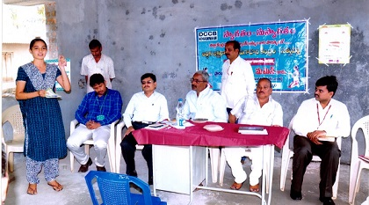
In “Kommepalle Village” of Sathupalli Mandal, Khammam District, the villagers were paid compensation for their lands acquired by M/S SCCL. The Compensation was paid thru bank. Subsequently, villagers have withdrawn entire compensation amounts, totalling to Rs.4 to 4.5 Crores and were ready to provide the funds to a Private Professional money lender for high rate of interest, exposing their funds to risk.
FLC Counseller, Ms.Md. Sartaj took special interest and conducted financial literacy camps in the village with the help of village elders. She explained the imminent risks involved in lending to professional money lenders and could convince them that safety of the fund itself is important to earn sustained interest income in future.
Convinced with the timely intervention of the FLC counsellor, the villagers one by one started keeping funds in DCCB and Rs.3.40 Crores was deposited back in the bank.
14.17.2: Counsellor, FLC Sathupally visited tribal villages where telugu language is not understood, and with the help of interpreters she conducted camps on PMJDY, PMJJBY & PMSBY in Yathalakunta and Thummalanagar villages where no villager is having bank account. With her efforts, she got opened 45 to 50 accounts in one day.
14.17.3 Ms.M.Vijayalaxmi, Business Correspondent of APGVB:
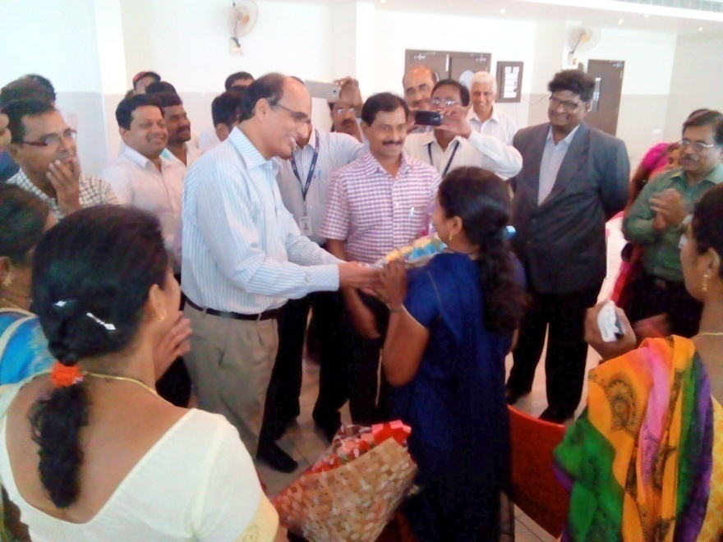
In accordance with the Financial Inclusion Plan, APGVB opened a Ultra Small Branch (USB) at Venkiryala village of Bibi Nagar (Mandal) Nalgonda Dist. To manage USB, they have selected Ms. Mekala Vijayalaxmi a Physically Challenged candidate and trained her. She started working as CSP (now Bank Mitra) from 19th May 2011. She had made a good business, by opening 1806 SB a/cs and 380 Recurring deposit a/cs. Due to the success of CSP, they opened a branch at Venkiryala on 25th March 2013. Even after opening of branch, M.Vijayalaxmi was allowed to continue as BC.
Chairman Sri V. Narasi Reddy felicitated M. Vijayalaxmi on her success as CSP in the training programme conducted to CSPs (Bank Mitras) at Bhongir on 3rd June 2015.

14.17.4 SBH - Rural Self Employment Training Institute (RSETI) Chilkur:
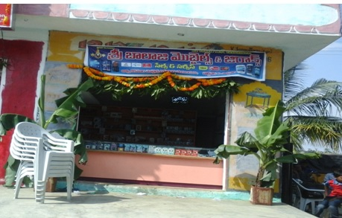
Sri.CH.Nagaraju S/o Ananthaiah, aged 22 years is a resident of Peddaumenthal, Pudur Mandal, Ranga Reddy District.
Nagaraju hails from a very poor family. He discontinued Intermediate, because of the financial problem of the family. He was doing small Mobile repairs in the local area.
Having seen the advertisement given by RSETI, Chilkur on the “skill training in Mobile servicing”, he joined the Mobile servicing training course.
Benefited by the training at RSETI, he established a mobile servicing shop earning Rs.250-300/- per day and is able to take care of his parents also.

14.17.5:
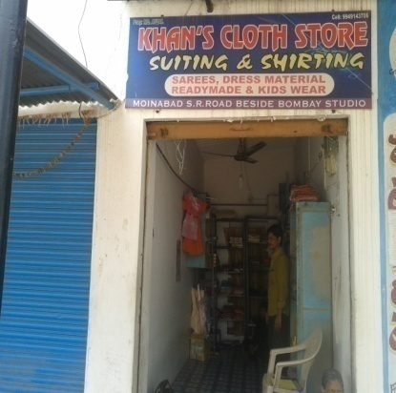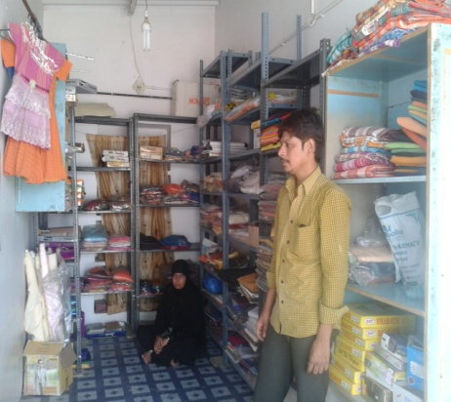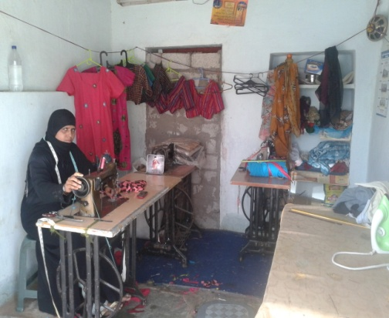
Smt Habib Sulthana W/o Md.Afzal was trained in Dress Designing. Her Husband was already running a hosiery shop in Moinabad. After the training, she started a tailoring shop at Moinabad, and earning Rs.600/- per day.
14.17.6
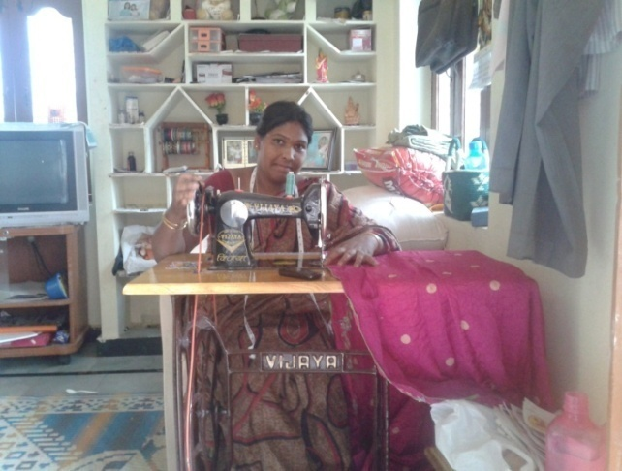
Smt. K.Vijaya was trained in Dress Designing. Immediately after the training, she started work at her home only and earning Rs.150/- per day.

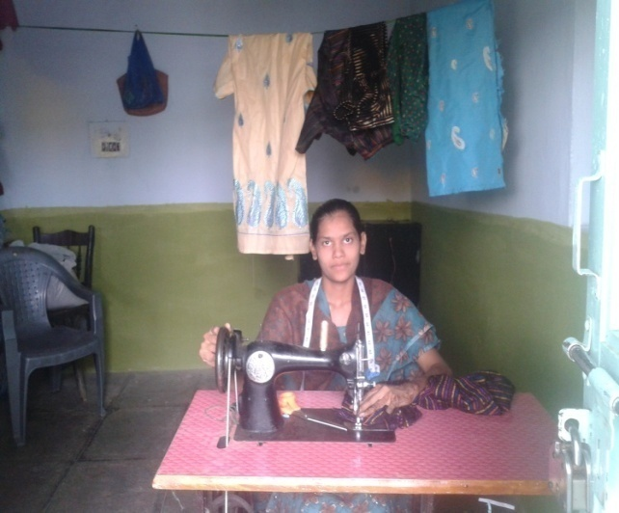

14.17.7:
Smt. Asha Begum W/o Md.Sattar was trained in Dress Designing. She started working from her home only at Moinabad and earning Rs.100/- to 150/- per day.

Agenda 15: Lead Bank Scheme
15.1 Attendance in JMLBC/DLRC/DCC Meetings:
Banks are advised to attend all JMLBC/DLRC/DCC meetings regularly and ensure 100% attendance in the meetings and participate in the deliberations.
It is brought to the notice of SLBC that in some districts due to non participation by the controllers of banks and representatives of Banks DCC/DLRC meetings were postponed by the District Collectors. This is a very serious concern and all banks are advised to take corrective steps and ensure attendance at appropriate level in JMLBC/DCC/DLRC meetings.

LDMs are advised to maintain the attendance of meetings and inform the absentees to their controlling authorities.
15.2 Information to be submitted quarterly by banks and LDMs:
All Banks and LDMs are advised to submit the quarterly information to be submitted to SLBC within 15 days from the end of the respective quarter to enable the SLBC to consolidate the position and to convene the SLBC meetings as per schedule.
The delay in submission leads to delay in conducting of SLBC meetings. Hence, All banks and LDMs are advised to submit the data well on time to adhere to the time schedule of SLBC meetings smoothly.
15.3 Communicating the decisions taken at SLBC level to the branches by the controlling authorities:

It is brought to the notice of SLBC by few Govt. Departments and LDMs that the decisions taken at the SLBC / Steering Committee / Sub-committee level are not being sent to the branches by the respective controlling offices which is causing avoidable delays in the implementation of guidelines.
All Banks are advised to ensure that the decisions taken at the SLBC level are intimated to their branches immediately to enable the banks to implement at the field level.

15.4 Strengthening of LDM’s Office:
It is observed that some of the Office of LDMs are yet to be provided with the necessary staff, independent offices, etc. The Ministry of Finance, GoI and RBI have been regularly reviewing the position and advising SLBC and the Controlling Authorities of Lead Banks to initiate the required steps for improving the infrastructure at LDM offices.
Controlling Authorities of Lead banks are requested to provide the necessary infrastructure at LDM’s Office for effective functioning.

Agenda – 16:
16.1 Overdue / NPA position: Overdue / NPAs position as on 30.09.2015 under various sectors (Amt. in cr.)

Sector | Outstanding |  | Overdue |  |  | NPAs
Sector | No. of A/c. | Amout | A/c. | Total balance in overdue accounts | Actual overdue amount | A/c. | Amount
Short Term crop production advances | 4450623 | 31553.05 | 573287 | 5754.75 | 3370.76 | 186373 | 1730.27
Agri. Term loans incl. Agric allied activities | 842448 | 13984.96 | 189946 | 3392.48 | 1698.04 | 99652 | 1332.78
Agr. Infrastructure | 10272 | 931.51 | 991 | 175.43 | 75.67 | 761 | 28.35
Agr. Ancillary | 135373 | 5633.39 | 6581 | 1370.94 | 608.45 | 4662 | 474.82
Total Agri. Advances | 5438716 | 52102.91 | 770805 | 10693.6 | 5752.92 | 291448 | 3566.22
MSME Sector advances | 671949 | 35837.48 | 124496 | 8913.59 | 5165.66 | 80786 | 3745.38
Others'under Priority Sector Advances | 554736 | 27533.81 | 78579 | 4677.01 | 611.21 | 37959 | 1334.25
Export credit | 118 | 100.69 | 11 | 43.62 | 22.62 | 0 | 0.00
Total Priority Sector Advances | 6665519 | 115574.89 | 973891 | 24327.82 | 11552.41 | 410193 | 8645.85
Non-Priority Sector Advances | 4118490 | 235309.99 | 225468 | 35468.63 | 12407.24 | 322420 | 16019.31
Total advances | 10784009 | 350884.88 | 1199359 | 59796.45 | 23959.65 | 732613 | 24665.16
Break-up of Others'under PSA
Education Loans | 88016 | 3239.95 | 15612 | 478.22 | 114.01 | 6245 | 131.50
Housing Loans | 273369 | 17569.01 | 47843 | 2940.50 | 309.79 | 18167 | 450.40
Others | 193351 | 6724.85 | 15124 | 1258.29 | 187.41 | 13547 | 752.35

- Bank-wise position on overdues / NPAs in ‘Others’ under priority sector advances is enclosed as Annexure 37.
- Bank-wise position on overdues / NPAs under Total Priority Sector advances is enclosed as Annexure 38.
- Bank-wise position on overdues / NPAs under Non-Priority Sector advances is enclosed as Annexure 39.
- Bank-wise position on overdues / NPAs under Total Advances is enclosed as Annexure 40.

16.2 Overdue / NPAs position under State Government sponsored scheme as on 30.09.2015 (Rs. In cr)
S.No. | Particu-lars | Outstanding |  | Overdues |  |  | NPAs
S.No. | Particu-lars | A/c. | Amt | No. of overdue A/c. | Total Balance in overdue a/c. | Actual overdue amount | No.of A/c. | Amount
1 | State Govt schemes | 2580433 | 46321.15 | 636859 | 15721.66 | 5382.34 | 241692 | 3829.45  (8.27%)

- Under State Government sponsored schemes, 8.27% of total outstandings are NPAs with an amount of Rs. 3829.45 cr.
- 11.62% of advances are overdue out of total outstanding State Govt. sponsored schemes advances.

16.3 Overdue / NPAs position under State Government sponsored scheme as on 30.09.2015 (Rs. In cr)

 | Scheme | Overdues including NPAs as on 30.09.2015 |  |  | Out of Total Overdues, NPAs as on 30.09.2015
 | Scheme | No.of A/cs | Total Balance in overdue A/cs | Actual overdue amount | No.of A/cs | Amount
 | State Government Sponsored Schemes (Total of i to xx) | 636856 | 15721.66 | 5382.34 | 241692 | 3829.45
i | APMIP | 1135 | 18.68 | 18.02 | 996 | 17.03
ii | RKVY | 1109 | 13.80 | 5.83 | 758 | 4.17
iii | Water Resources Development | 267 | 2.09 | 1.86 | 256 | 1.94
iv | Animal husbandry / Milch Animal Units (including Pasukarnthi Pathakam) | 8859 | 68.81 | 41.72 | 7042 | 35.06
v | Sheeep & Goat (including Jeevakranthi Pathakam) | 4075 | 33.88 | 25.26 | 2885 | 22.34
vi | Fisheries - GSS | 604 | 25.62 | 22.95 | 501 | 21.85
vii | Horticulture | 248 | 12.87 | 9.87 | 220 | 8.34
viii | Poly-house | 0 | 0.00 | 0.00 | 0 | 0.00
ix | Sericulture | 2423 | 23.12 | 11.42 | 1499 | 14.43
x | SERP (SHG Bank Linkage - Rural) | 32284 | 609.31 | 423.28 | 19670 | 340.57
xi | MEPMA (SHG Bank Linkage -Urban) | 10835 | 163.07 | 110.29 | 6285 | 76.98
xii | Weavers Credit Cards | 490 | 0.56 | 0.37 | 424 | 0.44
xiii | Handloom Weavers Groups | 843 | 9.84 | 6.51 | 608 | 6.36
xiv | S.C.Action Plan | 64868 | 275.80 | 249.02 | 55664 | 224.68
xv | S.T.Action Plan | 25899 | 200.19 | 178.25 | 21967 | 173.32
xvi | B.C.Action Plan | 86945 | 360.11 | 337.00 | 52902 | 326.12
xvii | Minorities Finance Corpn. | 20642 | 150.57 | 129.27 | 15956 | 136.24
xviii | Christian Finance Corpn. | 3552 | 16.02 | 11.77 | 2479 | 12.10
xviiii | Rajiv Gruhakalpa | 9306 | 82.50 | 49.59 | 8055 | 74.21
xx | VAMBAY | 2349 | 28.93 | 27.36 | 2309 | 27.53
xxi | Rajiv Yuva Sakthi | 6985 | 32.52 | 27.57 | 5398 | 28.06
xxii | Renewable Sources of Energy | 0 | 0.00 | 0.00 | 0 | 0.00
xxiii | Economic Rehabilitation Scheme for Disabled | 0 | 0.00 | 0.00 | 2 | 0.00
xxiv | Others | 353138 | 13593.38 | 3695.16 | 35816 | 2277.71

- APMIP: 26.00% of the loans extended under APMIP scheme by banks in Telangana are overdue and 24.57% of the loans are NPAs which is quite high.
- RKVY: 11.45% of the loans extended to milch animal units by banks in Telangana are overdue and 8.19% of the loans are NPAs which is quite high.
- Water Resources Development units: 15.88% of the loans extended to milch animal units by banks in Telangana are overdue and 16.57% of the loans are NPAs which is quite high.
- Milch animal units: 27.30% of the loans extended to milch animal units by banks in Telangana are overdue and 22.95% of the loans are NPAs which is quite high.
- Sheep & Goat: 47.66% of the loans extended to sheet & goat units by banks in Telangana are overdue and 42.15% of the loans are NPAs which s quite high.
- Fisheries-GSS: 23.83% of the loans extended to fisheries groups by banks in Telangana are overdue and 22.70% of the loans are NPAs which is quite high.
- Horticulture units: 41.49% of the loans extended to horticulture units by banks in Telangana are overdue and 35.05% of the loans are NPAs which is quite high.
- SERP: 10.84% of the loans extended under SERP by banks in Telangana are overdue and 8.72% of the loans are NPAs which is quite high.
- MEPMA: 7.67% of the loans extended under MEPMA by banks in Telangana are overdue and 5.36% of the loans are NPAs which is quite high.
- Handloom weavers groups: 36.88% of the loans extended to Handloom weavers groups by banks in Telangana are overdue and 36.01% of the loans are NPAs which is quite high.
- SC Corporation: 27.96% of the loans extended to SC beneficiares by banks in Telangana are overdue and 25.22% of the loans are NPAs which is quite high.
- ST Corporation: 44.18% of the loans extended to ST beneficiaries by banks in Telangana are overdue and 42.96% of the loans are NPAs which is quite high.
- BC Corporation: 29.44% of the loans extended to BC beneficiaries by banks in Telangana are overdue and 28.49% of the loans are NPAs which is quite high.
- Minorities Corporation: 28.83% of the loans extended to minorities community by banks in Telangana are overdue and 30.38% of the loans are NPAs which is quite high.
- Rajeev Gruhakalpa: 22.85% of the loans extended under Rajeev Gruhakalpa by banks in Telangana are overdue and 34.19% of the loans are NPAs which is quite high.
- VAMBAY: 38.20% of the loans extended under VAMBAY scheme by banks in Telangana are overdue and 38.43% of the loans are NPAs which is quite high.
- Rajeev Yuva Shakti: 28.88% of the loans extended beneficiaries under Rajeev Yuva Shakti by banks in Telangana are overdue and 29.40% of the loans are NPAs which is quite high.
- As all the loans extended under Govt. Sponsored schemes are registering increase in NPAs, we request the State Government to pass on necessary directions to the concerned departments to assist the banks in recovery to enable the banks to make fresh grounding within the time frame.

16.4 Overdue / NPAs position under Central Government sponsored schemes as on 30.09.2015 (Rs. In cr)
 | Scheme | Overdues including NPAs as on 30.09.2015 |  |  | Out of Total Overdues, NPAs as on 30.09.2015
 |  | No.of A/cs | Total Balance in overdue A/cs | Actual overdue amount | No.of A/cs | Amount
1 | Central Government Sponsored Schemes(total of i to x) | 58053 | 2270.46 | 1711.48 | 30137 | 1590.89
i | SGSY / NRLM | 25187 | 1151.58 | 764.28 | 10358 | 702.33
ii | SJSRY / NULM | 2400 | 313.40 | 308.30 | 1751 | 310.21
iii | PMRY / PMEGP | 20143 | 531.45 | 438.93 | 11734 | 392.43
vii | ISHUP / RRY | 614 | 77.08 | 77.37 | 542 | 77.46
viii | Agri Clinics / Agri Business Centres | 172 | 41.09 | 39.50 | 34 | 38.47
ix | Dairy Entrepreneurship Develoment Scheme | 9537 | 141.65 | 68.89 | 5718 | 55.79
x | Renewable Sources of Energy | 0 | 9.47 | 9.47 | 0 | 9.47
xi | Farmer Producer Organisation | 0 | 4.74 | 4.74 | 0 | 4.74
Central Govt. Sponsored schemes: 32.58% of outstandings in Central Government sponsored schemes are overdues and 30.55% of the outstandings are NPAs.
SGSY/NRLM schemes: 22.74% of outstandings in SGSY scheme are overdues and 20.90% of the outstandings are NPAs.
SJSRY/NULM schemes: 40.26% of outstandings in SJSRY scheme are overdues and 40.51% of the outstandings are NPAs.
PMRY/PMEGP schemes: 61.16% of outstandings in PMRY / PMEGP scheme are overdues and 54.68% of the outstandings are NPAs.
ISHUP/RRY schemes: 95.54% of outstandings in ISHUP/PRY are overdues and 95.66% of the outstandings are NPAs.
Agri Clinic / Agri business centres: 64.15% of outstandings in Agri. Clinics / agri. Business centres scheme are identified by banks as overdues and 62.47% of the outstandings are NPAs.
Dairy Entrepreneurship Development scheme: 33.77% of outstandings in Dairy Entrepreneurship Development scheme are identified by banks as overdues and 27.35% of the outstandings are NPAs.
Renewable sources of energy: 78.07% of outstandings in Renewable sources of Energy scheme are identified by banks as overdues and 78.07% of the outstandings are NPAs.
Farmer Producer Organisations: 98.54% of outstandings in Renewable sources of Energy scheme are identified by banks as overdues and 98.54% of the outstandings are NPAs.

Agenda—17:
Regional Rural Banks
  - Performance of Regional Rural Banks on important parameters
Regional Rural Banks’ main focus of lending is to Agriculture and allied activities in rural, semi-urban and urban area. Reserve Bank of India, NABARD and Sponsored Banks are reviewing the performance of RRBS at regular intervals.
  - Net work in Telangana
(Rs. In crore)
S.No | Name of the RRB | No. Of branches as on 30.06.14 | No. Of branches as on 31.03.15 | No. of branches as on 31.06.15 | No. of branches as on 30.09.15
1 | TGB | 303 | 332 | 332 | 332
2 | APGVB | 474 | 474 | 474 | 474
 | TOTAL | 777 | 806 | 806 | 806
17.3 Deposits
(Rs. In crore)
S.No | Name of the RRB | 31.3.14 | 31.03.15 | 30.06.15 | 30.09.15
1 | TGB | 4155.43 | 4890.25 | 4835.35 | 4953.89
2 | APGVB | 4930.00 | 5716.35 | 5691.81 | 5816.99
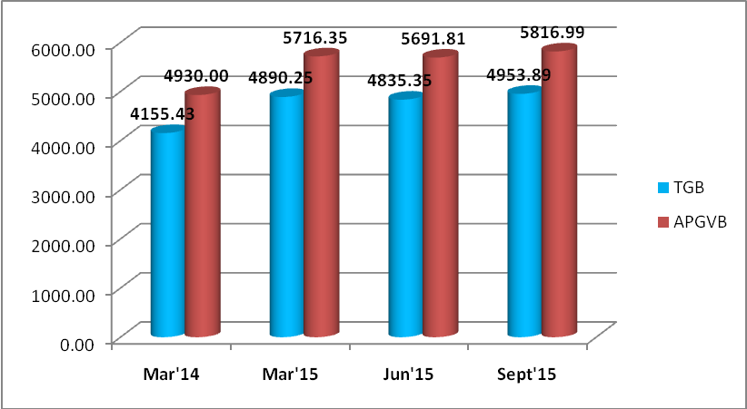
- During the quarter, TGB has registered a growth of Rs. 118.54 cr (2.45%) in deposits.
- Similarly, APGVB has also registered a growth of Rs. 125.18 cr (2.20%) during the quarter.
17.4 Advances: (Rs. In crore)
S.No | Name of the RRB | 31.3.14 | 31.03.15 | 30.06.15 | 30.09.15
1 | TGB | 3531.10 | 4162.54 | 4073.85 | 4126.54
2 | APGVB | 5877.00 | 6827.67 | 6801.09 | 6942.16
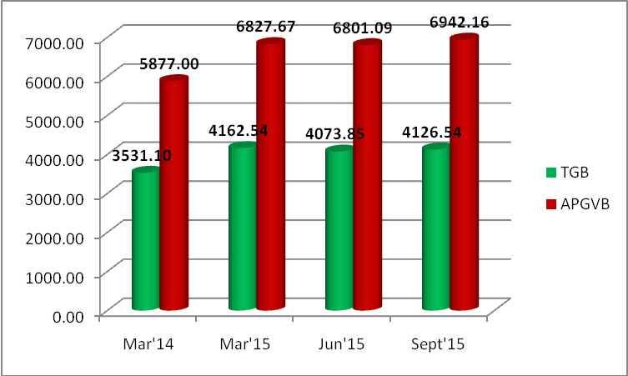
- TGB has registered a growth of Rs. 52.69 cr in advances during the quarter.
- Similarly, APGVB also registered a growth of Rs. 141.07 cr during the quarter.
17.5 C D Ratio (%)

S.No | Name of the RRB | 31.3.14 | 31.03.15 | 30.06.15 | 30.09.15
1 | TGB | 84.97% | 85.12% | 84.25% | 83.30%
2 | APGVB | 119.20% | 119.44% | 119.48% | 119.34%
- TGS and APGVB have registered CD ratio of 83.30% and 119.34% respectively.

17.6. Total Agri. Advances % in total advances (Rs.in cr)

S.No. | Name of the RRBs | Total Advances outstanding as on |  |  | Total Agricultural advances outstanding as on
S.No. | Name of the RRBs | 31.03.15 | 30.06.15 | 30.09.15 | 31.03.15 | 30.06.15 | 30.09.15
1 | TGB | 4162.54 | 4073.85 | 4126.54 | 2769.09 | 2673.82 | 2801.59
% of agriculture advances to total advances |  |  |  |  | 66.52% | 65.63% | 67.89%
2 | APGVB | 6827.67 | 6801.09 | 6942.16 | 5155.84 | 4368.19 | 4364.55
% of agriculture advances to total advances |  |  |  |  | 75.51% | 64.23% | 62.87%
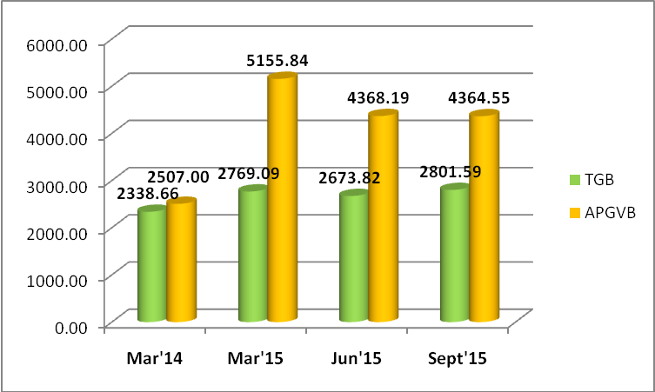
- Percentage of agriculture advances out of total advances is similar for both RRBs are above 60%.
17.7 Break-up of Total Agricultural advances (Rs. In cr)

S.No | Name of the RRB | Crop Loans |  |  |  | Term Loans
S.No | Name of the RRB | 31.3.14 | 31.03.15 | 30.06.15 | 30.09.15 | 31.03.14 | 31.03.15 | 30.06.15 | 30.09.15
1 | DGB | 1299.45 | 1440.55 | 1468.66 | 1624.57 | 113.13 | 1328.54 | 1205.16 | 1177.01
2 | APGVB | 2374.00 | 3937.86 | 2889.09 | 2861.91 | 1133.00 | 1217.98 | 1479.10 | 1502.64

Break-up of Agriculture Advances : Telangana Grameena Bank
(Rs. In cr)
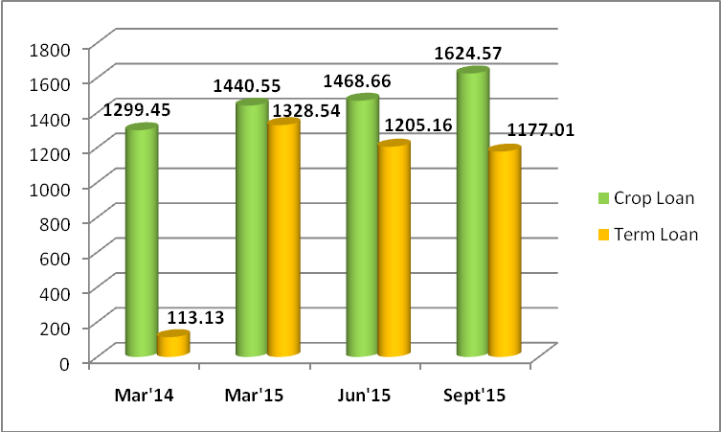
Break-up of Agriculture Advances : APGVB
(Rs. In cr)
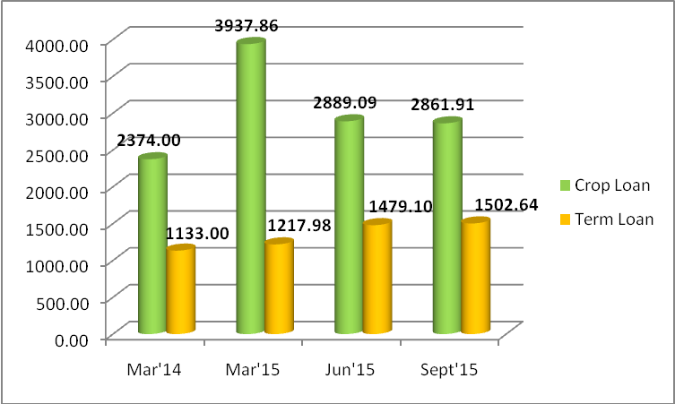

Agenda 18: To be discussed:

18.1 NULM:
As per the direction of the Government of India, Reserve Bank of India has advised vide cir. no RPCD.CO.LBS.BC.No. 2939/02.13.001/2015-16 dated the 23rd November 2015 to make necessary arrangements to include NULM as an agenda in the sub-committee of SLBC that monitors NRLM. RBI notification is enclosed an Annexure no. 78. Sub-committee on SHGs has been constituted and 1st meeting has been held on 22nd December 2015.

18.2 Loans under MUDRA scheme:
MSME Department Institute, Govt. of India, Hyderabad, vide their letter no. D(SI)/H/86(2)/2015-16/2736 dated the 16th November 2015 (copy enclosed as Annexure 79), has requested us to inform the banks about the lists of trained candidates in the Institute. The lists were sent (for information) to banks in Telangana state to explore financing of MSME-DI trained candidates. We request the banks to look into the matter and act suitably.

18.3 Allotment of land to RSETI-Khammam:
The issue of allotment of Government land to RSETI has been persisting for long. The land allotted in 2010 by the Government is litigated and on two different occasions, latest of which was in June 2015, the bank had to cancel the Bhoomi-pooja as the same litigant party served notice on the Bank.
The Ministry of Rural Development, GOI has set the timeline for construction of building for the RSETI at Khammam failing which they have informed that they would withdraw the corpus grant of the RSETI building already sanctioned. As per notification of MoRD, GOI, grant once withdrawn will not be sanctioned further under any circumstances and in that case the District will be deprived of a State-of-the Art infrastructure aimed to empower the rural youth, forever.
In this regard, the Management of State Bank of Hyderabad is requesting Govt. Of Telangana to look into the matter and allot alternative site for the constructions of RSETI. The District Administration alternatively may examine the possibility of allotting an acre of land at the existing site ‘Tharuni Haat” where the RESTI is presently located in a rented building of DRDA. (Letter received from SBH is enclosed as Annexure 80.)

18.4 District wise targets – PMEGP scheme of KVIC:
Khadi and Village Industries Commission has submitted revised tentative district-wise PMEGP targets for the year 2015-16. After approval in the SLBC meeting, the same will be sent to districts with directions to allot the bank-wise targets in their concerned districts for the year 2015-16. The communication of KVIC is Annexured as no. 81.

18.5 As per the direction of Govt. of India, NABARD vide their letter no. NB.TS /CPD-A6/4339 dated the 3rd December advised us to include the following as agenda items:
- Finance for rural housing
- Startup India programme
- Financial literacy awareness programmes by commercial banks
- Implementation of Atal Pension Yojna
- Solar Power V-SAT connectivity in sub-service areas
- Meeting of steering committee at regular intervals for special talks like financial inclusion.
The related papers are enclosed as Annexure no. 82.

18.6 Skill loan financing:
Department of Financial Services, Ministry of Finance, GoI vide letter F.No.6(4)/2014-CP-IF-II dated 30th June, 2015 (copy enclosed as Annexure 83) informed that Ministry of Skill Development and Entrepreneurship has formulated a revised ‘Model Scheme for Skill Loans’. Details about the scheme will be conveyed in due course.

DFS requested SLBC to include Skill Loans financing as a separate agenda in SLBC meeting to give impetus and to attain scale under skill loans quickly.

18.7 Inclusion of members in the SLBC meetings:
M/s. Sa-Dhan is the largest association of Microfinance Secton with institution membership of 245 comprising various legal entities. Sa-dhan is also the Self Regulatory Organisation recognized by RBI. It is also having membership in Andhra Pradesh SLBC before separation of the State. Some of the members of Sa-dhan are also operating in various districts of Telangana and requested us to include Sa-dhan as a member of Telangana also for attending the SLBC meetings. (Letter received from M/s. Sa-Dhan is enclosed as Annexure 84).

18.8 OSS Centres under TRIGP – Allotment of Gram Panchayats for BC Operations:

CEO, SERP, Govt. of Telangana, has requested APGVB to allot 276 Grampanchayat Centres with the population of 5000 and above, where the broadband connectivity is available, to enable them to proceed with the procurement of Hardwareand make other necessary arrangements i.e., identifying BCAs, training, internet connectivity, etc. for establishing ‘One Stop Shops (OSS) with Stree Nidhi as Business Correspondent. It is also proposed to make the paymens of Social Security Pensions (SSP) and MGNREGS wages through these OSSs. APGVB is in a position to provide banking services in all the service area villages through the Bank Mitras and has already started making DBT payments wherever the amount has been released to the customers of the Bank as per the guidelines issued by Govt. of India.

The Bank has already entered into service agreement with the Corporate BC for providing end-to-end solution for the implementation of financial inclusion plan (FIP) in all the service area villages under SSA concept.

At this juncture, the Bank is not a position to allot the villages to Stree Nidhi for establishment of OSS and also concerned that with the establishment of OSS in the villages operated by the BCs will adversely affect the viability of the entire BC model and smooth implementation of the Financial Inclusion Plan. In this APGVB requested to take up the issue with Govt. about this matter. (Letter enclosed as Annexure 85).

18.9 Drought – Declaration of 231 mandals in 7 districts of the State as drought affected:
Govt. of Telangana vide GO.MS.No. 6 dated the 24th November 2015 declare that drought exists during the South-West Monsoon during the current financial year 2015-16 in the 231 mandals. All the Lead District Managers were advised to conduct special DCC meetings to put the relief measures as per RBI guidelines, in place by banks in the districts. All the controllers of the banks are requested to issue necessary guidelines to the branches functioning under their control to implement the Spl. DCC resolutions. The GO issued by the Govt. of Telangana is enclosed an Annexure 86.
18.10 Housing for All (Urban) under Pradhan Mantri Awas Yojana:
Ministry of Housing and Urban Poverty Alleviation (MoHUPA) has launched a new mission on Housing for All (HFA) on 25th June, 2015 covering the urban poor under Pradhan Mantri Awas Yojana.
The HFA scheme entails (4) major components:
Vertical Components | Central Assistance
Centrally sponsored scheme
Slum Redevelopment | Rs.1.00 lakh
Affordable Housing in partnership | Rs.1.50 lakhs
Beneficiary led individual house construction or enhancement | Rs.1.50 lakhs
Central Sector Scheme
Credit Linked Subsidy | Upfront subsidy of 6.5% upto a max of Rs.2.30 lakhs for a max. loan of Rs.6.00 lakhs

As per the scheme guidelines Principal Secretary / Secretary to Government, Housing Department is notified as State Level Nodal Agency (SLNA) for the state of Telangana vide G.O.Rt.No.316, Municipal Administration and Urban development (UBS) Department dt: 13.08.2015.
The Government has constituted State Level Sanctioning and Monitoring Committee (SLSMC) under Housing for All mission vide G.O.Rt.No.384 Housing Municipal Administration & Urban Development (UBS) epartment dt: 29.09.2015. (copy of the GO are enclosed as Annexure 87).
73 cities/ULBs were identified for implementation of HFA during the year 2015-16. The list of ULBs identified as follows.
District | Municipality
Hyderabad | Hyderabad (GHMC) - 52 Locations
Karimnagar | Chintakunta
 | Kothapalli
 | Karimnagar Municipality
 | Sircilla - Mandepally
 | Metpally - Ammakapet
Medak | Gajwel - Sangapur
 | Zaheerabad – Shantinagar slum
 | Medak - Pillikotiyala
 | Medak – Someshwara wada
Mahabubnagar | Nagar-kurnool - Vuyyalawada
 | Wanaparthy – Chityala Road
 | Achampet – Rajeev Nagar Colony
Nalgonda | Gollaguda
 | Bhongir
Nizamabad | Bodhan – Narsapur Village
 | Armoor - Ashoknagar
Adilabad | Nirmal
Khammam | Palvancha
RR Dist | Vikarabad – Gangaram
Warangal | Janagaon - Vaddarabasti
 | Mahabubabad

Secretary (Housing), Govt. of Telangana highlighted following points with GOI.
- Except for projects in GHMC, the sale price of the houses is NIL as the state has decided to bear the entire balance sum under the 2 BHK housing programme of the state after incorporating the GOI share @ 1.50 lac per EWS house.
- The houses would be registered in the joint names of husband and wife with a lock in period of prohibition of sale of houses for 7 years so that the possibility of selling off the houses in open market and squatting on some other land parcel can be avoided.
Central Sanctioning and Monitoring Committee (CSMC) after detailed deliberation, gave its ‘in-principal’ approval to provide Central Assistance of Rs.71,061 lack @ 1.50 per EWS house for 47374 EWS houses of 73 AHP projects from 19 towns in Telangana and recommended the release of 1st instalment of 40% of the total Central Sharing amounting to Rs.28424.40 lac which would be considered on verification of the select DPRs for these 73 AHP (Affordable Housing in Partnership) projects.
Dwelling unit area and unit cost and financing pattern:
Financing Pattern | Under AHP & Benf. Led Construction  (Rs. in Lakhs)
GoI share | 1.50
GoT (Subsidy, Bank Loan & Beneficiary contribution) | 3.80
Infrastructure (GoT grant) | 0.75
Total Unit cost | 6.05

Agenda – 19:
19.1 Circulars issued by RBI:
- RBI/2015-16/10, BR.CO.RRB.BL.BC.No.17/31.01.002/2015-16 dated the 1st July 2015 – issued guidelines with regard to Brach Licensing.
- RBI/2015-16/29, FIDD.FID.BC.No.02/12.01.033/2015-16 dated the 1st July 2015 – issued guidelines with regard to SHG-Bank Linkage Programme
- RBI/2015-16/37, DBR.No.Dir.BC.97/13.03.00/2015-16 dated the 1st July 2015 – issued guidelines with regard to Interest Rate of Advances.
- RBI/2015-16/46, DBR.No.Dir/BC.13/08.12.001/2015-16 dated the 1st July 2015 – issued guidelines with regard to Housing Finance.
- RBI/2015-16/48, FIDD.CO.LBS.BC.No.3/02.01.001/2015-16 dated the 1st July 2015 – issued guidelines with regard to Lead Bank Scheme.
- RBI/2015-16/53, FIDD.CO.Plan.BC.No.04/04.09.01/2015-16 dated the 1st July 2015 – issued guidelines with regard to Priority Sector Lendings.
- RBI/2015-16/60,FIDD.CO.GSSD.BC.No.06/09.09.01/2015-16 dated the 1st July 2015 – issued guidelines with regard to Credit facilities to Scheduled Casts (SCs) & Scheduled Tribes (STs).
- RBI/2015-16/64, FIDD.GSSD.BC.No.05/09.10.01/2015-16 dated the 1st July 2015 – issued guidelines with regard to Credit facilities to Minority Communities.
- RBI/2015-16/68, FIDD.No. FSD.BC.No.01/05.10.001/2015-16 dated the 1st July 2015 – issued guidelines with regard to Guidelines for Relief Measures by Banks in areas affected by Natural Calamities.
- RBI/2015-16/74, FIDD.MSME & NFS.BC.No.07/06.02.31/2015-16 dated the 1st July 2015 – issued guidelines with regard to Lending to Micro, Small & Medium Enterprises (MSME) sector.
- RBI/2015-16/100, DBR.CID.BC.No.22/20.16.003/2015-16 dated the 1st July 2015 – issued guidelines with regard to Wilful Defaulters.
- RBI/2015-16/101, DBR..BP.BC.No.2/21.04.048/2015-16 dated the 1st July 2015 – issued guidelines with regard to Prudential Norms on Income Recognition, Asset Classification and Provisioning pertaining to Advances.
- RBI/2015-16/130, DCBR.BPD (PCB/RCB).Cir.No.1/16.20.000/2015-16 dated the 16th July 2015 – issued guidelines with regard to issue of ATM-cum-Debit Cards.
- RBI/2015-16/132, FIDD.CO.Plan.BC.No.08/04.09.01/2015-16 dated the 16th July 2015 – issued guidelines with regard to Priority Sector Lendings – Targets and Classification.
- RBI/2015-16/142, FIDD.GSSD.CO.BC.No.09/09.01.01/2015-16 dated the 30th July 2015 – issued guidelines with regard to National Rural Livelihhod Mission (NRLM).
- RBI/2015-16/141, FIDD.GSSD.CO.BC.No.10/09.16.03/2015-16 dated the 30th July 2015 – issued guidelines with regard to National Urban Livelihoods Mission (NULM).
- RBI/2015-16/152, FIDD.FSD.BC.No.59/05.04.02/2015-16 dated the 13th August 2015 – issued guidelines with regard to Union Budget 2015-16 – Interest Subvention Scheme.
- RBI/2015-16/156, FIDD.FSD.BC.No.12/05.10.001/2015-16 dated the 21st August 2015 – issued guidelines with regard to Relief Measures by Banks in Areas affected by Natural Calamities.
- RBI/2015-16/160, FIDD.MSME & NFS.BC.No.60/06.02.31/2015-16 dated the 27th August 2015 – issued guidelines with regard to Streamlining flow of Credit to Micro and Small Enterprises (MSEs) for facilitating timely and adequate credit flow during the ‘ Life Cycle’.

Agenda – 20:
20.1 Position of top 10 banks : Deposits.
(Rs. In lac)
1 | State Bank of Hyderabad | 6486442.00
2 | Andhra Bank | 4517233.14
3 | State Bank of India | 4245915.00
4 | HDFC Bank | 1922722.79
5 | ICICI Bank | 1805724.60
6 | Canara Bank | 1460733.27
7 | Syndicate Bank | 1202806.60
8 | Axis Bank | 1189339.53
9 | IDBI Bank | 739779.26
10 | Bank of India | 694248.00
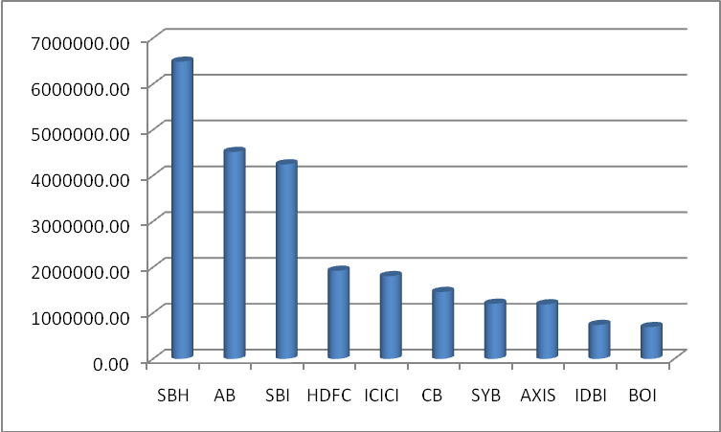

20.2 Position of top ten banks : Advances
(Rs. In lac)
1 | STATE BANK OF INDIA | 4994120.00
2 | STATE BANK OF HYDERABAD | 3807456.00
3 | ANDHRA BANK | 3514191.40
4 | HDFC BANK | 1893215.12
5 | ICICI BANK | 1803076.42
6 | CANARA BANK | 1592785.69
7 | AXIS BANK | 1505153.73
8 | INDIAN OVERSEAS BANK | 1362488.00
9 | IDBI BANK | 1251163.90
10 | BANK OF INDIA | 1217632.00
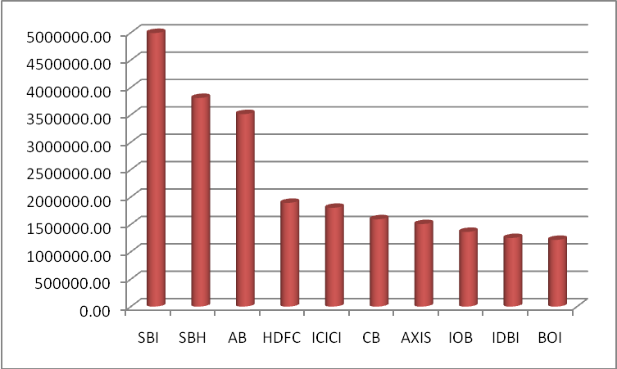

20.3 Position of top ten Banks : Total business
(Rs. In lac)
1 | State Bank of Hyderabad | 10293898.00
2 | State Bank of India | 9240035.00
3 | Andhra Bank | 8031424.54
4 | HDFC Bank | 3815937.91
5 | ICICI Bank | 3608801.02
6 | Canara Bank | 3053518.96
7 | Axis Bank | 2694493.26
8 | Syndicate Bank | 2260836.98
9 | Indian Overseas Bank | 2045219.00
10 | IDBI Bank | 1990943.16
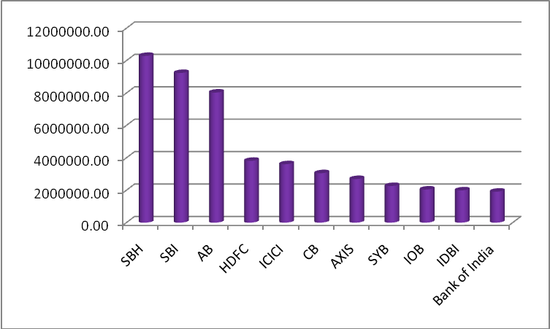

20.4 Outstanding of Micro; Small and Medium Enterprises as at Sep’ 2015
(Rs. In cr)
Bparticulas | Outstandings | % to Outstanding
Micro Enterprises | 24047.86 | 29.95%
Small Enterprises | 42219.37 | 52.58%
Medium Enterprises | 14031.43 | 17.47%
Total MSME | 80298.66 | 100.00%
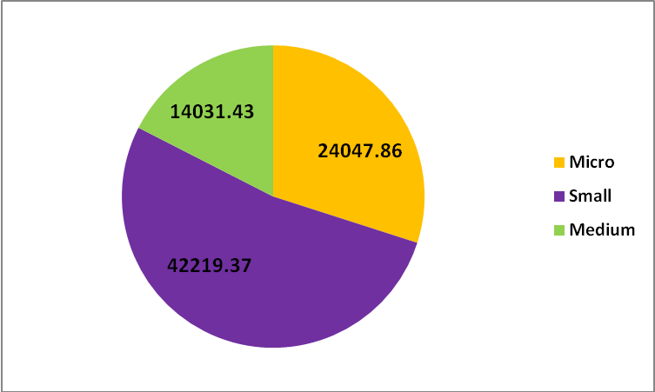

20.5 Position of top ten Banks : Total Priority Sector Advances
(Rs. In lac)
1 | State Bank of Hyderabad | 1846106.32
2 | Andhra Bank | 1359447.03
3 | State Bank of India | 1229428.00
4 | Indian Overseas Bank | 703364.42
5 | APGVB | 577178.69
6 | HDFC Bank | 555807.56
7 | Canara Bank | 409402.84
8 | A P State Co-op Bank | 403781.84
9 | Syndicate Bank | 379296.16
10 | DGB | 340416.85
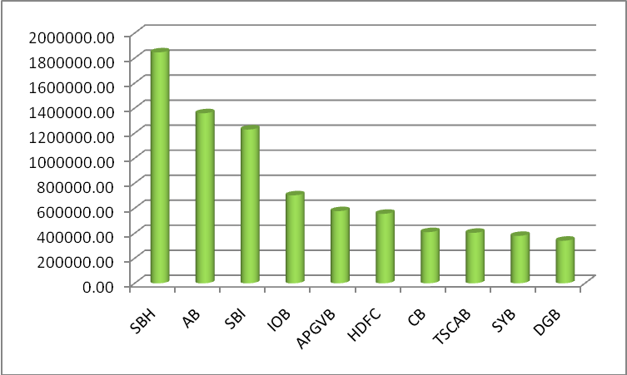

20.6 Break-up of Agriculture advances – Disbursals
(Rs. In lac)
Particulars | Disbursals | % to total disbursal
Crop Loans | 1293873.67 | 76.54%
Term Loans | 318186.36 | 18.82%
Agri. Infrastructure | 8292.17 | 0.49%
Agr. Ancillary activities | 70108.44 | 4.15%
Total Agriculture | 1690460.64 | 100.00%
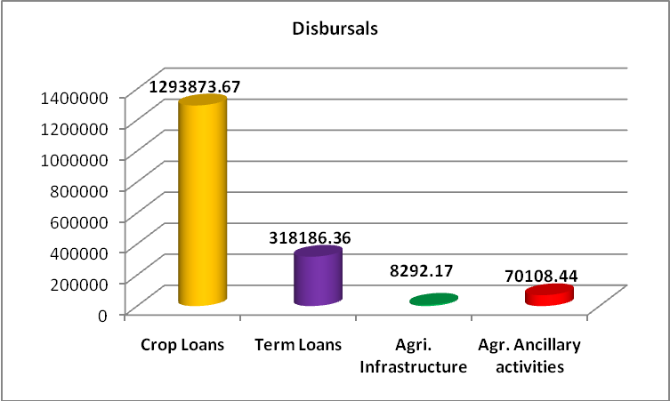

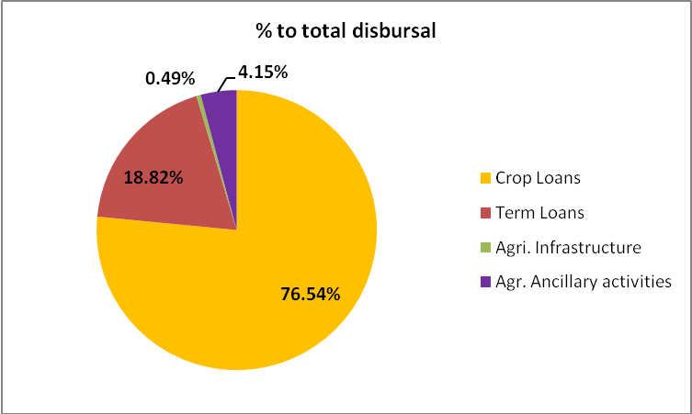
20.7 Break-up : Disbursements to Priority Sector Advances
(Rs. In lac)
Particulars | Disbursals | % to total disbursal
Agriculture Segment | 1690460.65 | 57.95%
MSME Segment | 923965.59 | 31.68%
Others | 302457.3 | 10.37%
Total Disbursement | 2916883.54 | 100.00%
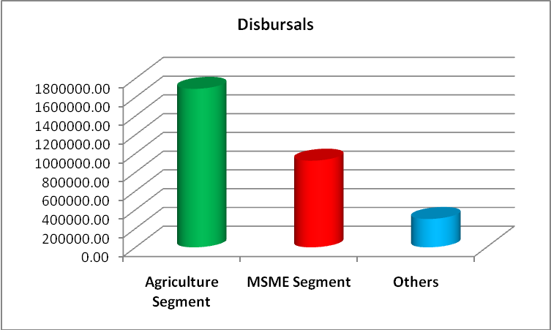

Break-up of priority sector advances – disbursals segment wise (%)
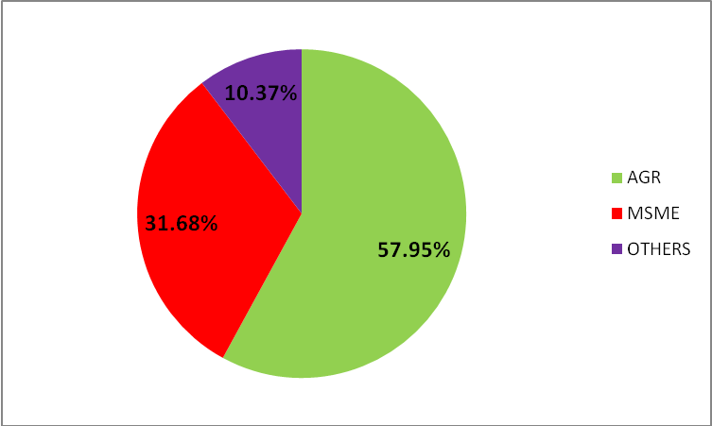
20.8 Break-up of disbursements in Priority sector advances activity wise (Rs. In lac)
Particulars | Disbursement | % to total disbursement
Crop Loans | 1293873.67 | 44.36%
Agr Term Loans | 318186.36 | 10.91%
Agr Infrastructure | 8292.17 | 0.28%
Agr Ancillary activities | 70108.44 | 2.40%
MSME | 923965.59 | 31.68%
Others | 302457.3 | 10.37%
Total disbursements to Priority sector advances | 2916883.53 | 100.00%
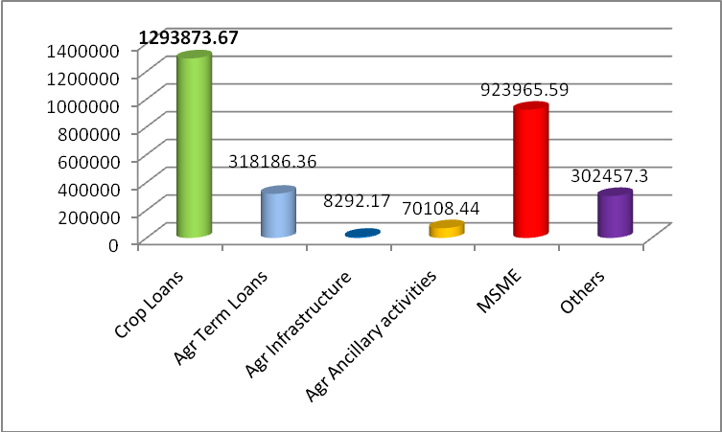

Disbursements of Priority sector advances - % wise
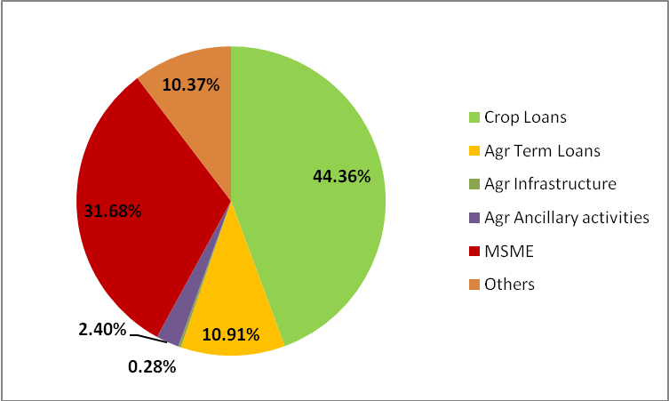
20.9 Acheivement of annual targets – segment-wise (%)


